Öresund – Kattegat – Skagerrak
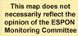
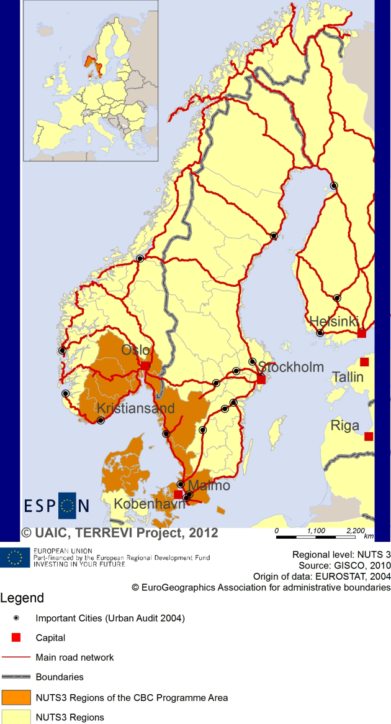

ESPON Project TERREVI
November 2012

Introduction
ESPON supports policy development in relation to the aim of territorial cohesion and a harmonious development of the European territory. It provides comparable information, evidence, analysis, and scenarios on territorial dynamics, which reveal territorial capitals and development potentials of regions and larger territories. Considering the programme area in its European context adds an important new perspective that can help shaping the programming and the places of implementing projects.
The ESPON TERREVI project focuses on producing evidence for Structural Funds programmes with the aim to support the development of the programmes to be carried out in the 2014-2020 period.
One milestone of this work consists in presenting selected ESPON research pieces in easy-to-understand factsheets for all territorial cooperation programme areas. The aim is to provide the reader with preliminary insight on types of territorial evidence ESPON holds at hand with regard to the possible investment priorities of future programmes. The factsheets certainly only give a first glimpse rather than fully present the work of the large number of ESPON projects that are currently underway. Likewise, each programme area includes diverse development potentials and challenges, which needs targeted information search. However, hopefully this factsheet will contain information, benchmarking the programme area in its larger, territorial context, that is of interest and help to better understand the programme area and to navigate within the richness of ESPON material available.
In addition to the programme factsheets there will be a number of specific programme case studies illustrating how ESPON material can be used to support the development of future programmes e.g. by giving a comparative European dimension to the envisaged SWOTs. These case studies will be carried out in early 2013.
This factsheet is structured in three main parts. The first part presents a selection of indicators that help comparing the situation of the programme area in question with the European average, the average for all programme areas as well as the situation in the countries involved. The second part briefly presents the territorial factors of interest for the programme area. The final part offers guidance on the further use of ESPON results and tools. This is intended as an electronic publication so map quality is generally high to allow users to zoom into specific territories.
This factsheet does not necessarily reflect the opinion of the ESPON Monitoring Committee.

Europe 2020
Europe, with its member states and their regions, is more exposed to global shocks and international competition than at any time before. As the world becomes more interdependent this trend will continue and shape policy thinking across sectors, borders and geographical scales. At the same time, Europe is characterised by a large territorial diversity meaning that global developments can imply rather different development possibilities and challenges for different European regions and cities.
The differences are partly defined by major geographical structures such as urban systems, access and connectivity, the geographical specificity or population density. At the same time, the differences are also spelled out in the larger development trends that affect an area, and the way and degree to which it is affected.
The data, indicators and territorial evidence provided by ESPON provides insight on both the main structures and larger territorial trends. The fine art is to identify what can actually be influenced by policy-making and, in particular, by place-based policy and territorial cooperation related to your programme area.
This chapter provides a selection of ESPON data related to Europe 2020 objectives of smart, sustainable and inclusive growth, giving also hints as regards the main thematic objectives envisaged in the draft regulations for the next period of EU Cohesion Policy. The Europe 2020 Strategy aims to enhance smart, sustainable and inclusive growth. This strategy has clear territorial dimensions. However, achieving these goals is challenging in the crisis-driven times. Furthermore, the economic disparities are growing as economic trends and the crisis have various impacts on different parts of Europe.
In the following the traffic light for each indicator represents how your programme territory compares to wider European and national medians where green = your programme area performs better for that indicator, yellow = similar, and red = worse.
In creating the traffic lights the median was used as central value indicator for all statistical variables due to its advantages (easy to interpret, it splits the statistical distribution in half) but especially due to the constraints linked to the impossibility of computing means for several indicators (Climate Change, Wind Energy Potential etc.). Therefore, a special attention should be given in reading the median values when the number of NUTS 2 regions is below 7. Using percentiles implies also a high dependence of the final results on the type of statistical distribution. This fact should be considered when establishing the relative position of a CBC Programme Area to a specific country.
EU 27+4 in Traffic Lights and box-plots means the EU Member States as well as Iceland, Liechtenstein, Norway and Switzerland – the ESPON space.

Smart growth
Smart growth refers to developing an economy based on knowledge and innovation. In the framework of the Europe 2020 Strategy it means improving the EU's performance in education, research/innovation and digital society.
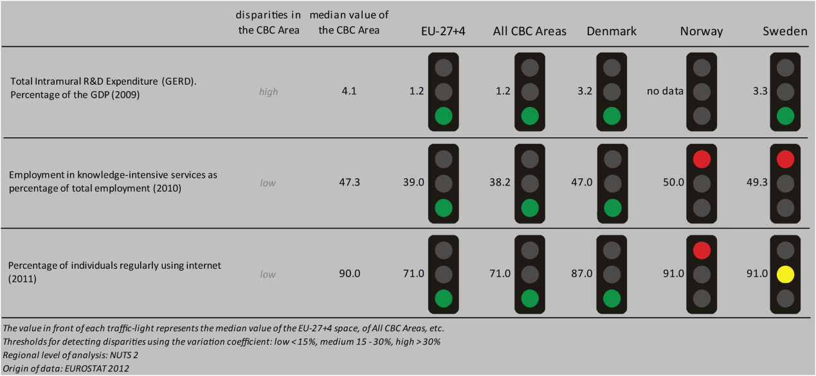
According to all indicators reported above, the Öresund - Kattegat – Skagerrak CBC area performs at a much better level than the EU27+4 space and all CBC ones. Considering the objective of R&D expenditure as a percentage of GDP - one of the five headline targets in the Europe 2020 Strategy - the CBC area is performing better than all European and national areas considered. However, the CBC area is characterised by a high level of internal disparity. Concerning the ratio of employment in knowledge-intensive services to the total employment in 2010, the CBC area is performing better than the EU27+4 space, all CBCs and Denmark. However, it is doing worse than Norway and Sweden. The distribution inside the CBC area results in a low level of internal disparity. In terms of percentage of individuals regularly using internet in 2011, the Öresund - Kattegat – Skagerrak CBC area has the same values as the EU27+4 space, all CBCs and Denmark, while doing the same than Sweden and worse than Norway, with small internal disparities.
According to the classification of the KIT project, MAP 1 identifies a varied pattern of innovation:
- ‘Applied science area’, in the Danish part incl. the largest island of Zealand. It is associated to a quite high generality and originality of science-based local knowledge, and a high degree of attractiveness of knowledge coming from other regions;
- ‘Smart technological application area’, in the Swedish and (mainland) Danish parts. It is defined by a high product innovation level, with a limited degree of local applied science and R&D endowment, and a high creativity which allows translating external basic science and applied science knowledge into innovation;
- ‘Smart and creative diversification area’ in the Norwegian part. It is defined by a low degree of local diversified applied knowledge, internal innovation capacity, high degree of local competences, creativity and entrepreneurship, external knowledge embedded in technical and organizational capabilities.

MAP 1 – Territorial Patterns of Innovation (ESPON KIT project) for the CBC Öresund – Kattegat – Skagerrak

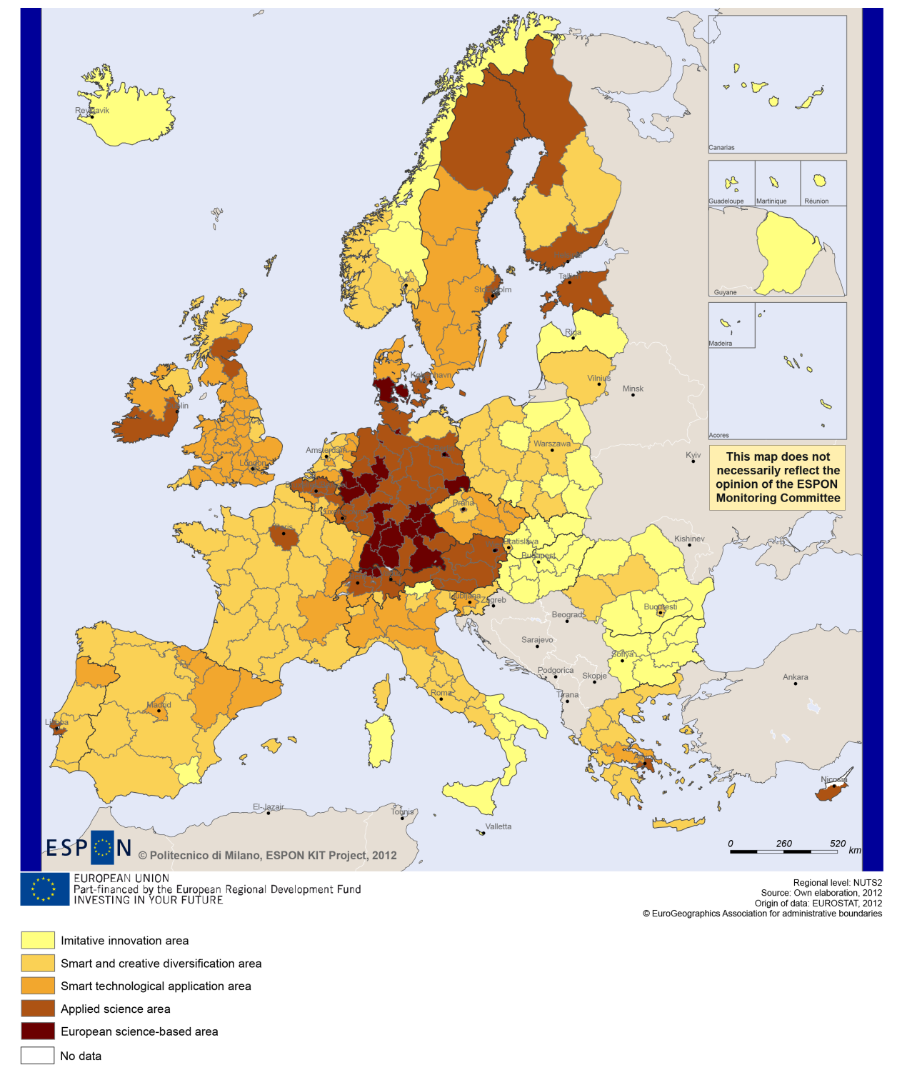

Sustainable growth
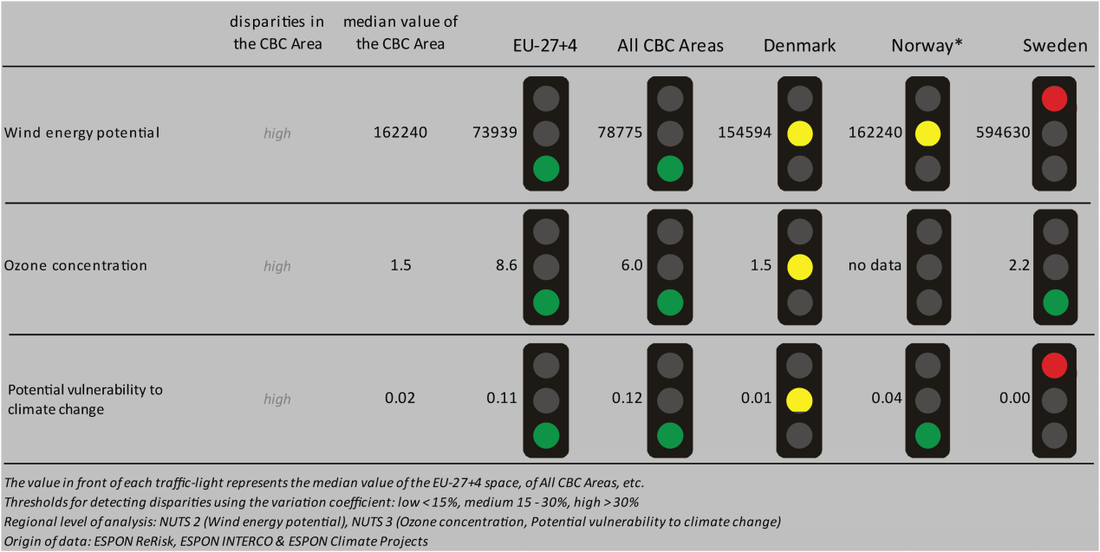
Sustainable growth refers to promoting a more resource efficient, greener and more competitive economy. Within the Europe 2020 Strategy it means e.g. building a more competitive low-carbon economy that makes efficient, sustainable use of resources, protecting the environment, reducing emissions and preventing biodiversity loss, capitalising on Europe's leadership in developing new green technologies and production methods, and introducing efficient smart electricity grids. In the framework of the Europe 2020 Strategy it means focus on competitiveness, resource efficiency, climate change and biodiversity.
The use of wind energy could be one of the cornerstones in building a competitive low-carbon economy in the EU. The CBC area of Öresund - Kattegat – Skagerrak has a strong potential in using this sustainable source of energy, as its median value considerably exceeds that of the EU-27+4 or all CBC areas. The median value for wind energy potential is in general at the same level as in Denmark or Norway, however, it is much below the Swedish national median. It has to be noted that Sweden has an extremely high level of wind energy potential in the European context. The level of ozone concentration is also much below the relevant values for the EU-27+4 or all CBC areas. Again it is similar to that of Denmark and slightly lower than that of Sweden (no data available for Norway). The CBC area’s potential vulnerability to climate change is at a very low (close to ‘0’) level, similarly to the level of all three partner-countries. Overall the programme area is potentially much less vulnerable to climate change than other EU-27+4 or CBC regions. All three indicators are characterised by high disparities within the CBC area, a situation also reflected in BOX-PLOT 2.
BOX-PLOT 2 on combined adaptive capacity to climate change mirrors the strong position of the programme area described by the sustainable growth indicators above. All border regions are in a highly ‘illustrious’ position when compared to other EU-27+4 or other CBC areas, as all of them fall within the upper 25% of all European regions (the Danish region of Byen København standing at the top of the range). The performance of the border-regions with regard to their combined adaptive capacity is more similar to the national levels. Four of the Danish border-regions, namely Byen København, Nordsjælland, Københavns omegn and Bornholm have very strong combined adaptive capacity even in the national context, while the Danish region of Vest- og Sydsjælland has a relatively weak adaptive capacity (one of the weakest among all border-regions and all Danish regions as well).
According to MAP 2, Directive 11 seem to have no particular territorial impact on fossil fuel consumption in most of the Denmark-Sweden-Norway border-area, with the exception of the Capital Region of Denmark (Region Hovestaden), where some minor impact has been detected.

MAP 2 - Territorial impact on fossil fuel consumption of Directive on the promotion of clean and energy-efficient road transport vehicles (ESPON ARTS project) for the CBC Öresund – Kattegat – Skagerrak

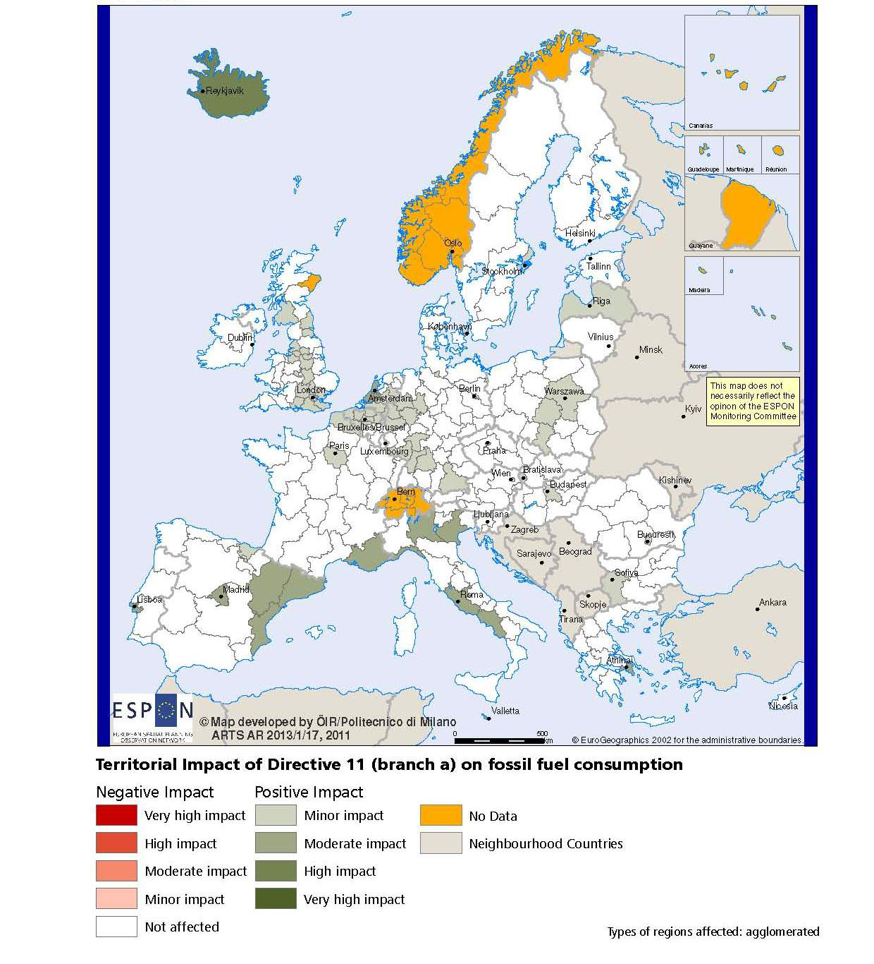

BOX-PLOT 1 – Combined adaptive capacity to climate change (ESPON CLIMATE project) for the CBC Öresund – Kattegat – Skagerrak
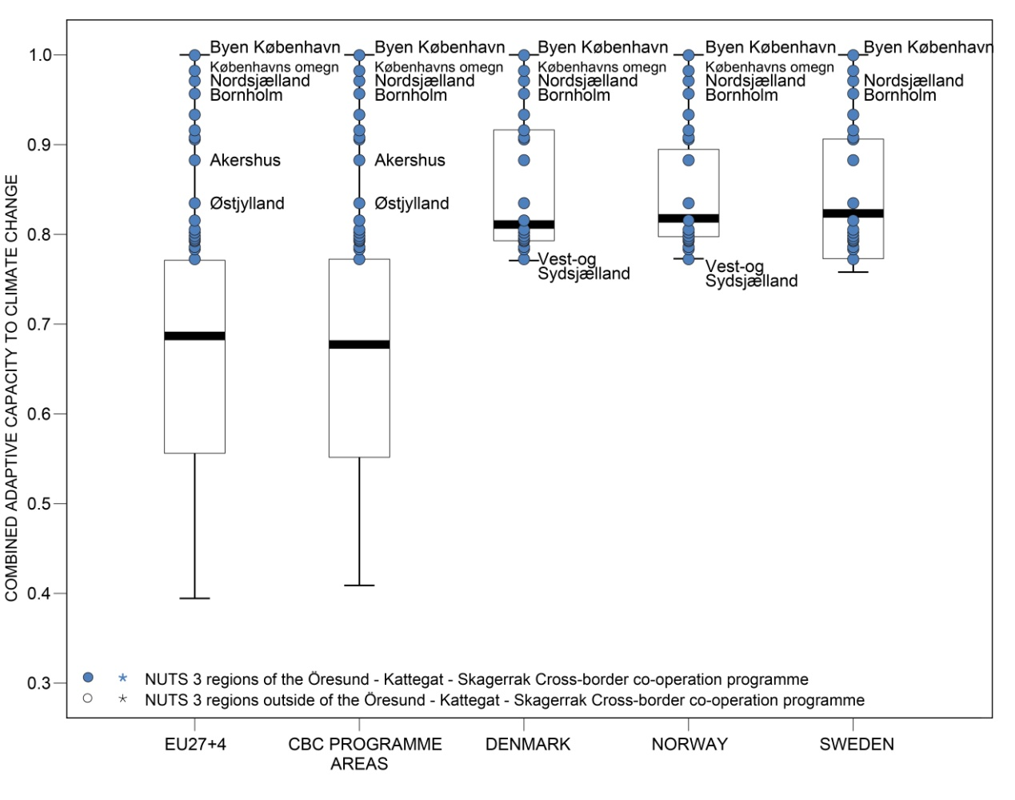
“Adaptive capacity (adaptability)” to climate change indicates the ability or potential of a system to respond successfully to climate change and variability, and includes adjustments in behaviour, resources and technologies.

How to read the box-plots?
The box-plot is a statistical and mathematical tool used to visualize numerical data sets and to compare its statistical distribution.
Because it is used in exploratory analysis of databases, this representation is sensitive to the quality of the central value selected to explain the symmetry, shape and distribution variability. In the case of a box-plot, the most used central value is the median, because it has the quality of sectioning the data string into two halves, so that 50% of the cases will be above the central value and the other half will be below it. Since the purpose of the representation is to highlight outliers’ behavior, it uses a box that encompasses half of the cases, i.e. values that are in the range defined by the percentile of 25% and 75%. If a region has a value in this box then it can be considered that it has, according to the variable in question, a situation close to the average behavior of all regions analyzed.
When a region consistently deviates from the average profile of the analyzed territorial context, this behavior will be noted in the chart only when certain thresholds of statistical tolerances are exceeded, this being pointed in the diagram with segments perpendicular to the middle box, segments called the "whiskers".

Inclusive growth
Inclusive growth refers to fostering a high-employment economy delivering social and territorial cohesion. Within the Europe 2020 Strategy it means raising Europe’s employment rate, helping people of all ages anticipate and manage change through investment in skills & training, modernising labour markets and welfare systems, and ensuring the benefits of growth reach all parts of the EU. In short the key factors are employment and avoiding risk of poverty and social exclusion.
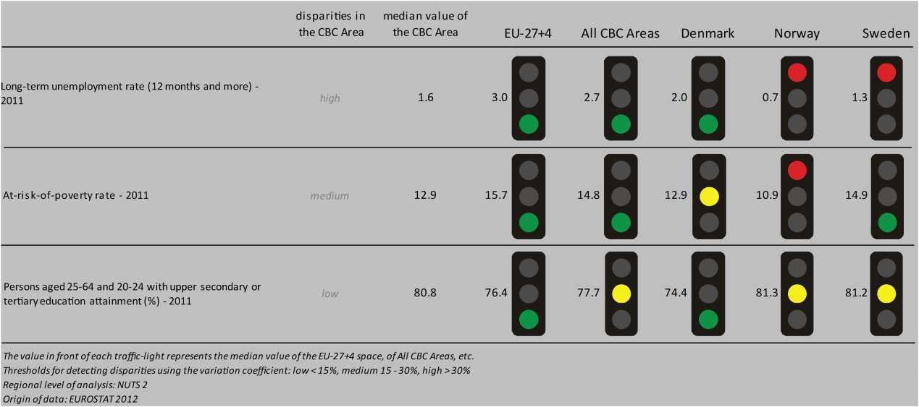
As far as the employment situation is concerned, the CBC area performs generally better than the EU-27+4 or other CBC areas according to the three selected indicators. The programme area is characterised by lower-level of long-term unemployment and the same rate of people at risk of poverty as Denmark. The CBC region’s rate of long-term unemployed and rate of people at risk of poverty are slightly higher than that of Norway. At the same time the CBC area counts relatively more unemployed people, but relatively fewer people at risk of poverty than Sweden in general. The level of persons (aged 20-64) with upper secondary or tertiary education attainment is the same as in Norway and Sweden, and higher than in Denmark.
The employment rate of the Swedish and Danish border-regions of the programme varies (no data are available for Norway). Some of the Danish regions, namely Østjylland, Østsjælland and Nordjylland have higher than average employment rate (and even fall within the upper 25% of all regions) in both the European and national contexts. Other regions have an employment level close to the European (EU-27+4 and all CBC) medians.
Predications made by the ESPON DEMIFER project on the changes in the European labour force until 2050 vary. On the Swedish side of the border three scenarios predict low to high level of increase in the labour force, and only the ‘Limited Social Europe’ scenario foresees minor decrease in the region of West Sweden (Halland and Västra Götaland). Three out of four scenarios expect mostly medium-level decrease in the labour force until 2050 in the Danish border-regions (except for a minor level increase predicted in the Capital region by the ‘Growing Social Europe’ scenario); while the ‘Expanding Market Europe’ scenario sees the labour force to increase to a medium-degree in the Capital region (Hovedstaden) and increase slightly also in the region of Zealand (Østsjælland and Vest- og Sydsjælland). Finally, in Norway two scenarios (namely ‘Growing Social Europe’ and ‘Expanding Market Europe’) predict medium to high level increase in the labour force; and other two (namely the ‘Limited Social Europe’ and ‘Challenged Market Europe’ scenarios) see a minor to medium-level increase in the regions of Aust-Agder, Vest-Agder, Oslo and Akershus, and a small decrease in the region of Sør-Østlandet (Østfold, Buskerud, Vestfold and Telemark).

MAP 3 – Change in Labour Force 2005-2050 (ESPON DEMIFER project) for the CBC Öresund – Kattegat – Skagerrak

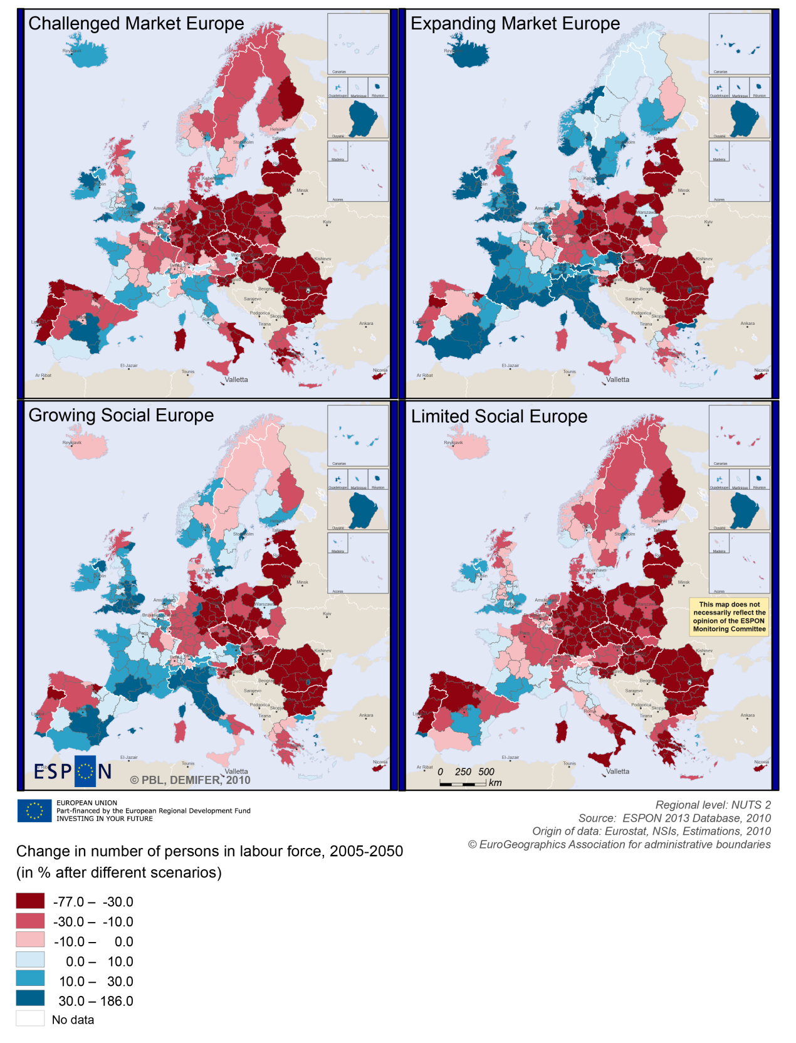

BOX-PLOT 2 – Employment rate 2010 within the CBC Öresund – Kattegat – Skagerrak
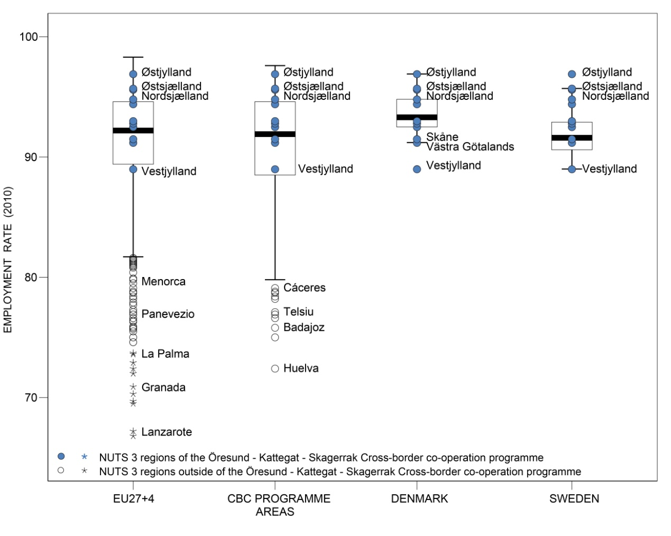

(see “How to read the box-plots?” on page 8)

Territorial factors of interest for the programme area
Territorial cooperation programmes can make a difference for the future development of cross-border and transnational territories in Europe. Some of the factors can be analysed by European wide data sets and using some studies having specific maps, figures and tables concerning the areas of the cooperation region.
In a European perspective, the programme area is mainly characterised by a composition of rural regions and intermediate regions (in-between rural and urban) and the urban regions of Oslo and Copenhagen. Some of the Danish and Norwegian regions are also characterised as remote. The urban centres in the programme area include e.g. Oslo, Gothenburg, Malmö-Lund, Copenhagen, Aarhus, Aalborg, and Kristiansand.
Compared to most other cross-border programme areas, the programme area is not a continuous land-area but divided into several parts by the sea. Both the mix of different types of regions from urban to remote rural and the separations by the sea come with a number of distinct development features, as does the presence of capital city regions such as Oslo and Copenhagen.
This can e.g. be noted with regard to the multimodal accessibility. Most parts of the programme areas have below average European multimodal accessibility. Only those areas with good access to a larger international airport have above average accessibility.
As regards geographical specificities, the programme area is largely characterised as coastal including a number of islands. ESPON GEOSPECS has developed a nexus models for coastal regions and islands linking defining features via intermediary process to development challenges and opportunities. The below figure is an example for coastal areas. These models can be of interest also for further developing the discussion about the challenges and opportunities in the programme area.
ESPON GEOSPECS PROJECT – FINAL REPORT, PAGE 103:
Nexus model for coastal areas
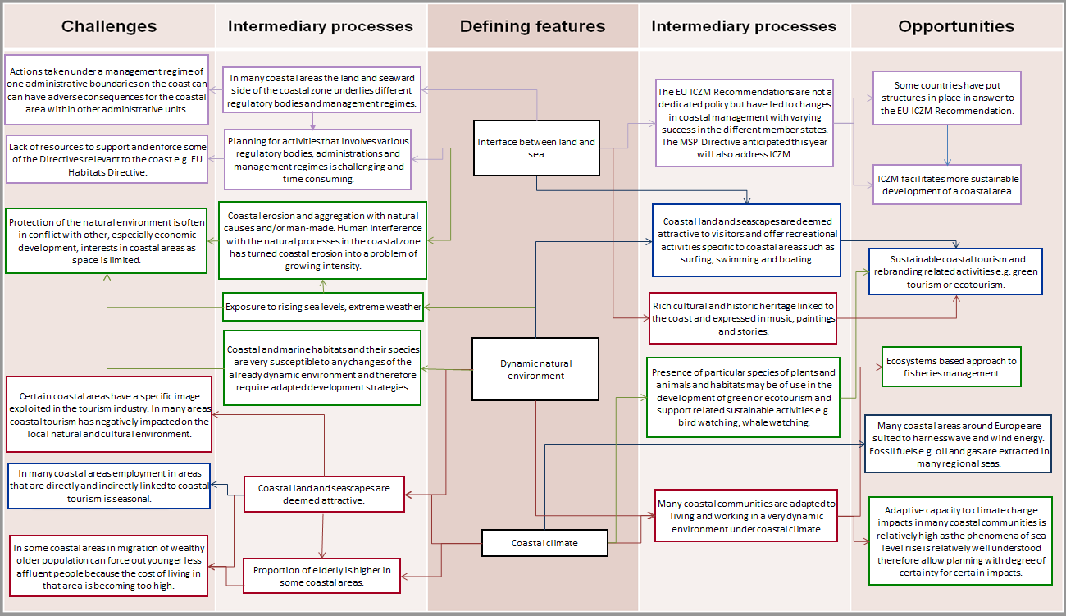

MAP 4 – Urban-rural typology of NUTS3 regions including remoteness (DG Regio) for the CBC Öresund – Kattegat – Skagerrak

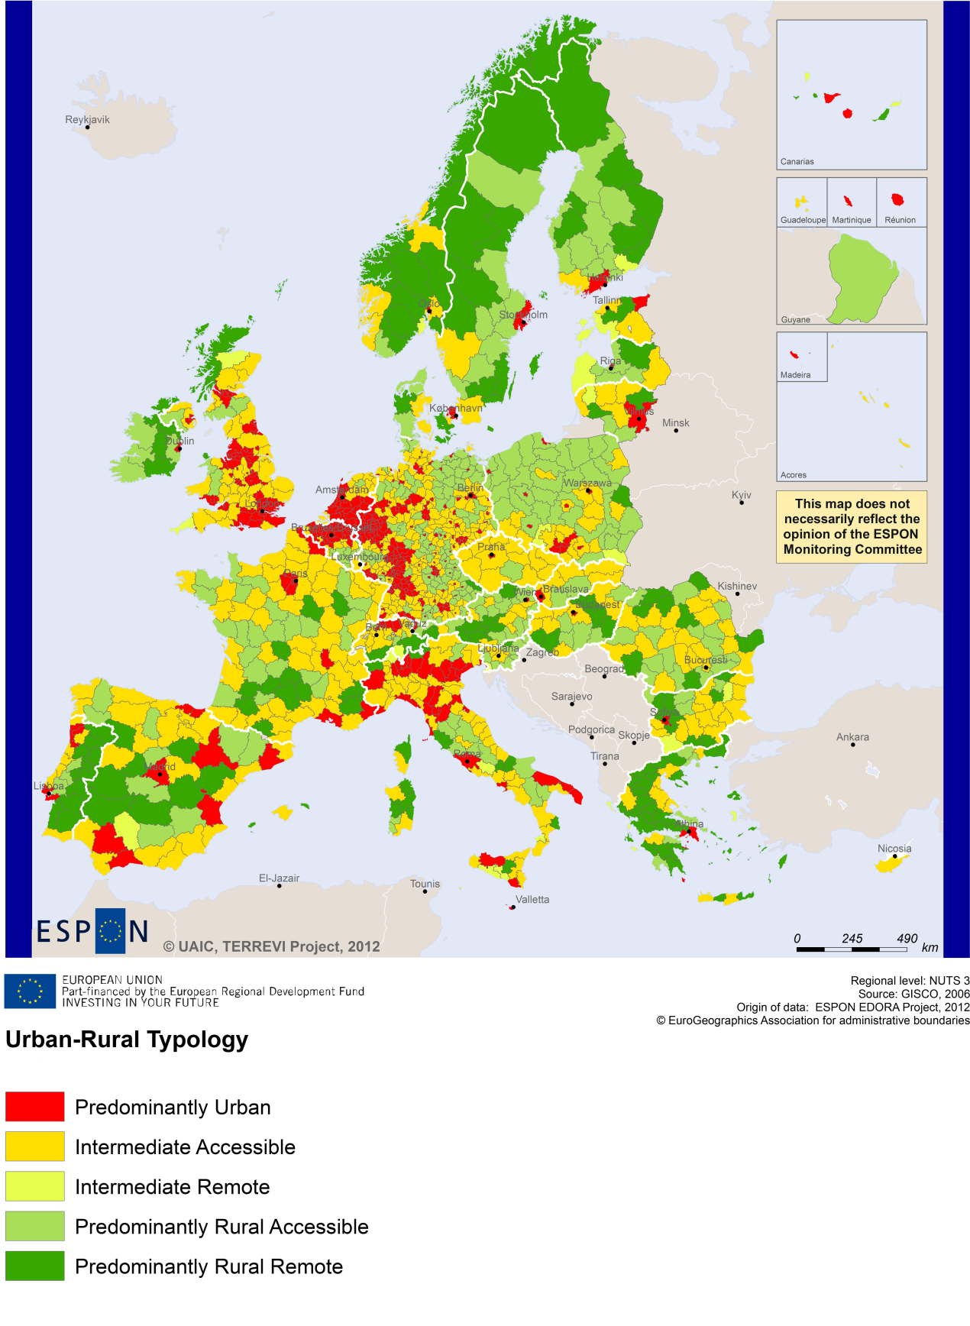

(Accessible=close to a city)

MAP 5 – Multimodal accessibilty (ESPON Accessibility Update) for the CBC Öresund – Kattegat – Skagerrak
“Potential Accessibility Multimodal” scores accessibility of NUTS 3 regions by road, rail and air relative to the European average in an Accessibility Index.
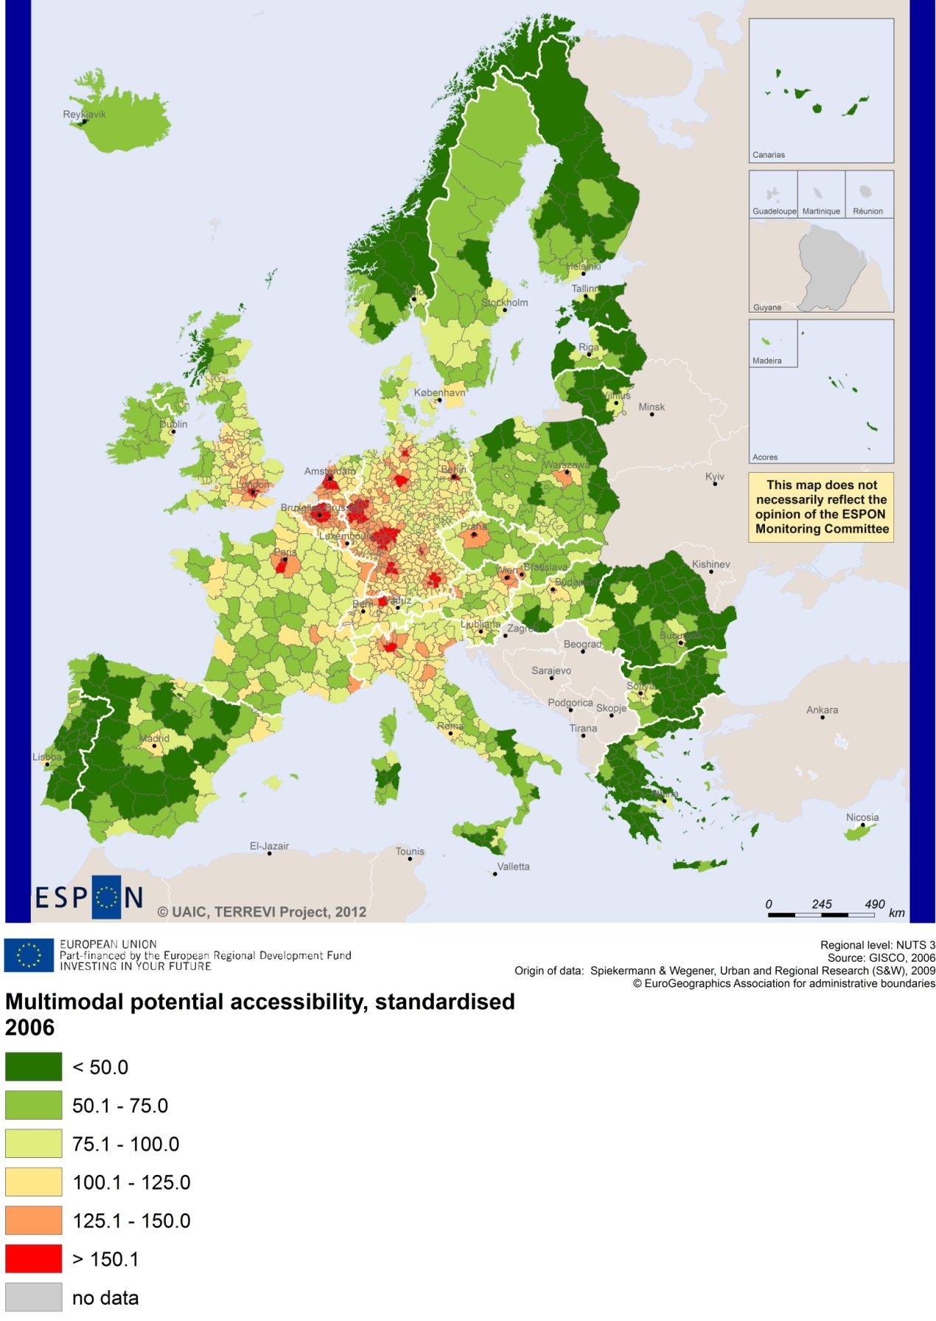

Recommended ESPON reading
ESPON provides an essential underpinning for translating into practice the calls for integrated and place-based approaches to economic development, when analysing a programme area or deciding about future programme priorities. ESPON has published a wide range of exciting reports providing valuable territorial evidence for future territorial cooperation initiatives.
The table below shows examples of relevant projects for the Cooperation Region. However, you have to study other ESPON reports as well in order to capitalise fully on the European information available for the cross-border programming.
ESPON study | Topic | Content
EDORA | Rural areas | It describes the opportunities of rural areas (see maps in Appendix 1).
CLIMATE | Climate change | It analyses the impact of climate change (see from map 1 to 23).
TIPTAP | Territorial impact assessment | It provides a tool for the ex-ante assessment of territorial impacts of policies to deliver evidence on the territorial impact of policies (see from map 2.3.1 to 2.3.9).
CAEE | Agglomerati-on economies | It aims at a better understanding of the economic costs and benefits of large urban agglomerations (see figure.1).
TRANSMEC | European cooperation | It describes the usefulness of ESPON to territorial cooperation programmes (see map 27, from map 36 to 39).
SEMIGRA | Rural migration | It describes migration in rural regions and development strategies (see map 1, 4 and 5).
KIT | Innovation | It describes knowledge and innovation economy potentials (see from map 3.1.1 to 4.4.1).
SGPTD | Growth poles | It analyses European secondary cities (see from figure 2 to 2.12).
TERCO | Territorial cooperation | It analyses Skåne län, Västra Götalands län, Hallands län and all Norwegian NUTS3 (see Main and Scientific report).
DEMIFER | Demography | It analyses migration and the region of Sydsverige (Annex D12/10).
ReRisk | Energy | It analyses clean and sustainable energies and the Danish Island of Samsø and Kalundborg and Landskrona (SE).
ATTREG | Attractiveness | It describes the economic impact of European regions and cities (see the case of the island of Bornholm,Annex 4/2).
EU LUPA | Land use | It focus on land use and in particular on the Öresund region and the Danish municipalities of Thy and Mors.
EURO-ISLANDS | Islands | It describes the Danish Island of Samsø was chosen as a case study (See Annex III to the Final Report).
PURR | Rural regions | It explores the potentials of rural areas and medium-sized towns (see the case of the municipality of Notodden).
ULYSSES | Cross-border development | It provides a “reference baseline” for new cross-border spatial development and analyses Öresundskomiteen.
RISE | Integrated strategies | It analyses the Regional Integrated Strategies, in particular in the Danish island of Zealand (see Annex 2).
Furthermore, some of overall ESPON products of particular interest for territorial cooperation are:
- ESPON Synthesis report “new evidence on smart, sustainable and inclusive territories” provides an easy to read overview on ESPON results available.
- ESPON Territorial Observations is a publication series, which on a few pages presents policy relevant findings deriving from latest ESPON research.
- ESPON 2013 Database provides regional information provided by ESPON projects and EUROSTAT.
- ESPON Hyperaltas allows comparing and analysing a region’s relative position at European, national and local scale for a wide range of criteria.
- ESPON MapFinder provides access to the most relevant ESPON maps resulting from ESPON projects and reports.
- ESPON Typologies provides nine regional typologies for additional analysis of regional data to be considered in the European context.
All ESPON reports and tools are freely available at
www.espon.eu
The ESPON 2013 Programme is part-financed by the European Regional Development Fund, the EU Member States and the Partner States Iceland, Liechtenstein, Norway and Switzerland. It shall support policy development in relation to the aim of territorial cohesion and a harmonious development of the European territory.

