North Sea
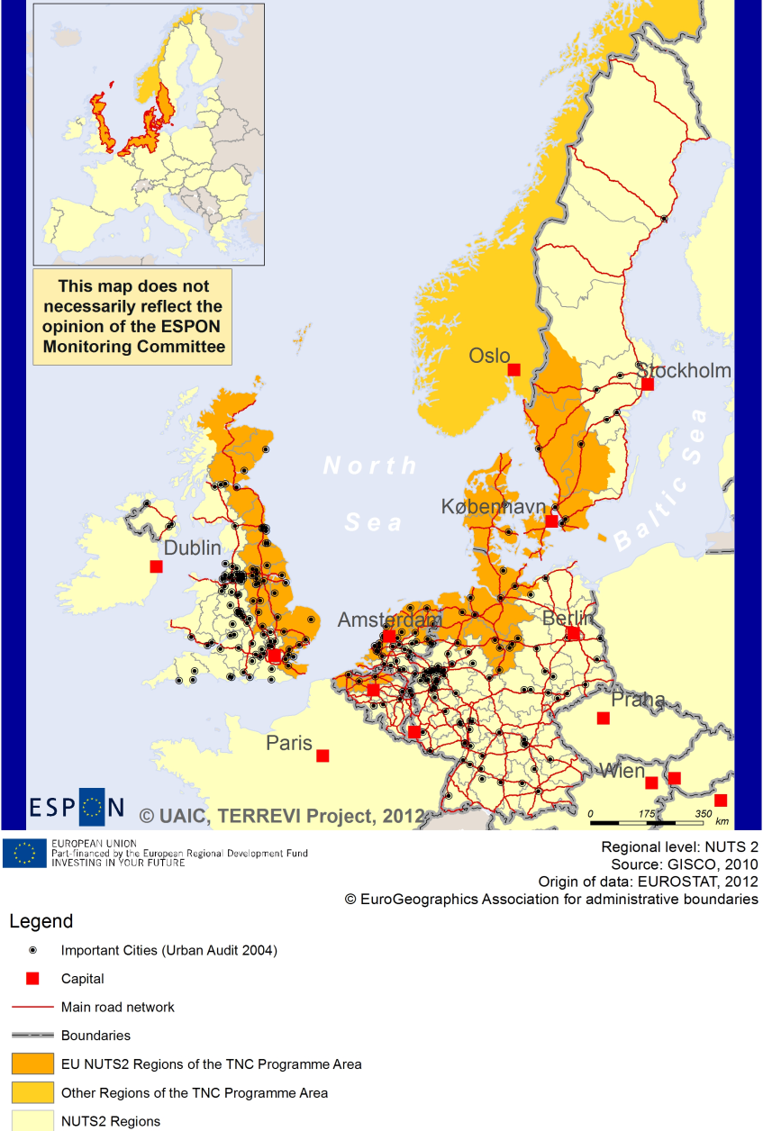

ESPON Project TERREVI
November 2012

Introduction
ESPON supports policy development in relation to the aim of territorial cohesion and a harmonious development of the European territory. It provides comparable information, evidence, analysis, and scenarios on territorial dynamics, which reveal territorial capitals and development potentials of regions and larger territories. Considering the programme area in its European context adds an important new perspective that can help shaping the programming and the places of implementing projects.
The ESPON TERREVI project focuses on producing evidence for Structural Funds programmes with the aim to support the development of the programmes to be carried out in the 2014-2020 period.
One milestone of this work consists in presenting selected ESPON research pieces in easy-to-understand factsheets for all territorial cooperation programme areas. The aim is to provide the reader with preliminary insight on types of territorial evidence ESPON holds at hand with regard to the possible investment priorities of future programmes. The factsheets certainly only give a first glimpse rather than fully present the work of the large number of ESPON projects that are currently underway. Likewise, each programme area includes diverse development potentials and challenges, which needs targeted information search. However, hopefully this factsheet will contain information, benchmarking the programme area in its larger, territorial context, that is of interest and help to better understand the programme area and to navigate within the richness of ESPON material available.
In addition to the programme factsheets there will be a number of specific programme case studies illustrating how ESPON material can be used to support the development of future programmes e.g. by giving a comparative European dimension to the envisaged SWOTs. These case studies will be carried out in early 2013
This factsheet is structured in three main parts. The first part presents a selection of indicators that help comparing the situation of the programme area in question with the European average, the average for all programme areas as well as the situation in the countries involved. The second part briefly presents the territorial factors of interest for the programme area. The final part offers guidance on the further use of ESPON results and tools. This is intended as an electronic publication so map quality is generally high to allow users to zoom into specific territories.
This factsheet does not necessarily reflect the opinion of the ESPON Monitoring Committee.

Europe 2020
Europe, with its member states and their regions, is more exposed to global shocks and international competition than at any time before. As the world becomes more interdependent this trend will continue and shape policy thinking across sectors, borders and geographical scales. At the same time, Europe is characterised by a large territorial diversity meaning that global developments can imply rather different development possibilities and challenges for different European regions and cities.
The differences are partly defined by major geographical structures such as urban systems, access and connectivity, the geographical specificity or population density. At the same time, the differences are also spelled out in the larger development trends that affect an area and the way and degree to which it is affected.
The data, indicators and territorial evidence provided by ESPON provides insight on both the main structures and larger territorial trends. The fine art is to identify what can actually be influenced by policy-making and, in particular, by place-based policy and territorial cooperation related to your programme area.
This chapter provides a selection of ESPON data related to Europe 2020 objectives of smart, sustainable and inclusive growth, giving also hints as regards the main thematic objectives envisaged in the draft regulations for the next period of EU Cohesion Policy. The Europe 2020 Strategy aims to enhance smart, sustainable and inclusive growth. This strategy has clear territorial dimensions. However, achieving these goals is challenging in the crisis-driven times. Furthermore, the economic disparities are growing as economic trends and the crisis have various impacts on different parts of Europe.
In the following the traffic light for each indicator represents how your programme territory compares to wider European medians where green = your programme area performs better for that indicator, yellow = similar, and red = worse.
The traffic lights below were created in order to graphically represent the situation of each analysed TNC Area compared to the one of the EU-27+4 space. The median value, calculated depending on the values registered for every NUTS 2/NUTS 3 region composing the programme area was used as the central value indicator. The median of the programme area was compared to the one computed for EU-27+4 territory.
EU 27+4 in traffic lights means the EU Member States as well as Iceland, Liechtenstein, Norway and Switzerland – the ESPON space.

Smart, Sustainable and Inclusive growth
Smart growth refers to developing an economy based on knowledge and innovation. In the framework of the Europe 2020 Strategy it means improving the EU's performance in education, research/innovation and digital society.
Sustainable growth refers to promoting a more resource efficient, greener and more competitive economy. Within the Europe 2020 Strategy it means e.g. building a more competitive low-carbon economy that makes efficient, sustainable use of resources, protecting the environment, reducing emissions and preventing biodiversity loss, capitalising on Europe's leadership in developing new green technologies and production methods, and introducing efficient smart electricity grids. In the framework of the Europe 2020 Strategy it means focus on competitiveness, resource efficiency, climate change and biodiversity.
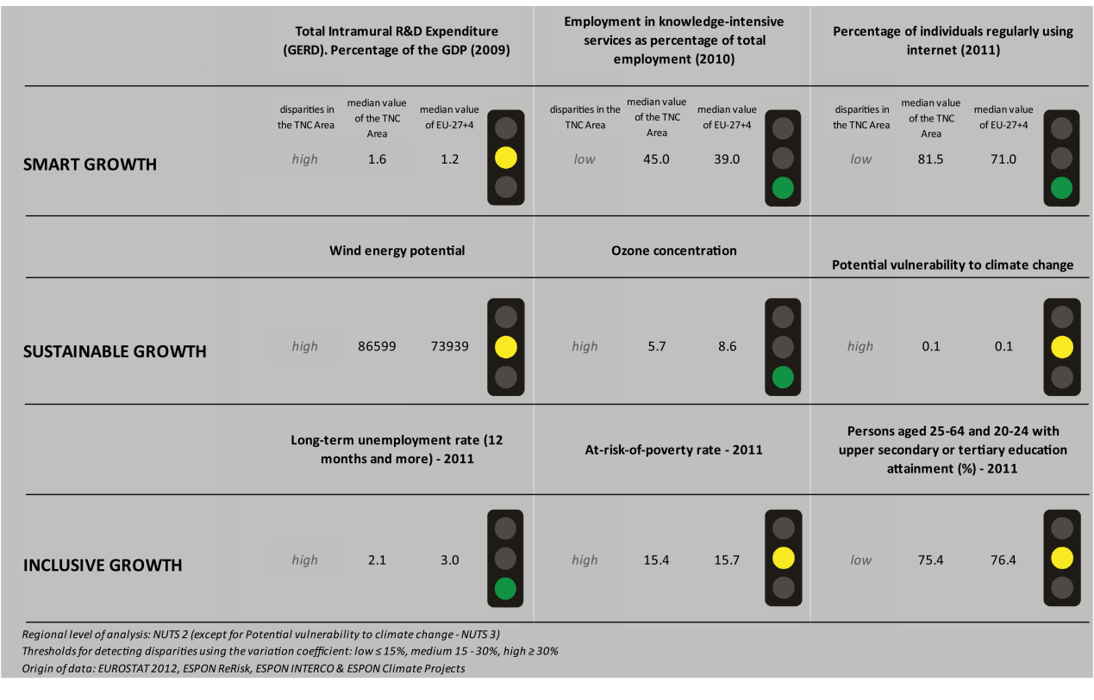
Inclusive growth refers to fostering a high-employment economy delivering social and territorial cohesion. Within the Europe 2020 Strategy it means raising Europe’s employment rate, helping people of all ages anticipate and manage change through investment in skills & training, modernising labour markets and welfare systems, and ensuring the benefits of growth reach all parts of the EU. In short the key factors are employment and avoiding risk of poverty and social exclusion.
Looking at the indicators for smart growth, the North Sea TNC area has more positive values compared to the EU27+4 (with regards to employment in knowledge-intensive services, and the number of persons regularly using the internet). With regards to R&D expenditure, the TNC area has also more positive values compared to the EU27+4 although it must be added that the disparities within the area are high.
Using the taxonomy of the KIT project, Map 1 shows a diversified and scattered situation in terms of patterns of innovation. In some parts of the TNC area (south of Denmark and North-West Germany), many Nuts-2 regions of the TNC area are either rated as “applied science-“ or “European science-based” areas due to a high level of science-based local knowledge and a high degree of attractiveness of knowledge coming from other regions. The other regions are mainly qualified as smart and creative diversification areas or smart technological application areas.
The indicators for sustainable growth vary for the North Sea TNC area. The wind energy potential of the TNC area is higher than the potential of the EU27+4 and has a high level of diversity within the area. In terms of ozone concentration, the North Sea shows less positive values than the EU27+4; however the disparities within the area are high. The TNC area seems to be as vulnerable to climate change as the EU27+4 with high disparities across its regions.
The disparities within the TNC area are also striking when looking at Map 3 which highlights the adaptive capacity to climate change. The south of Sweden and parts of German, Denmark and eastern Great Britain regions of the TNC area show higher capacity to adapt to climate change than the other regions.
The TNC area is generally not affected in terms of fossil fuel consumption by the Directive on the promotion of clean and energy-efficient road transport vehicles. The exceptions are a few regions in the Netherlands and Great Britain which seem to witness a minor positive impact.

Looking at the indicators for inclusive growth the long-term unemployment rate in the TNC area is lower than in the EU27+4. The at-risk-of-poverty rate is comparable to the EU27+4. Both show high disparities within the TNC area. The share of persons aged 25-64 and 20-24 with upper secondary or tertiary education attainment is comparable to the rate of the EU27+4.
Map 5 illustrates the diversity within the region with regards to the employment rates. Some parts of Germany and Great Britain of the TNC area experience higher employment rates than the outer regions within the North Sea area. In all four ESPON DEMIFER scenarios (Map 4), the south part regions of the TNC area (parts of Germany and Denmark) seem to experience more negative changes in labour market forces by 2050. In the scenarios “Growing social Europe” and “Expanding Market Europe” the changes in labour force seem to have positive outcomes also in the Scandinavian parts of the area.

MAP 1 – Territorial Patterns of Innovation (ESPON KIT project) for the TNC North Sea

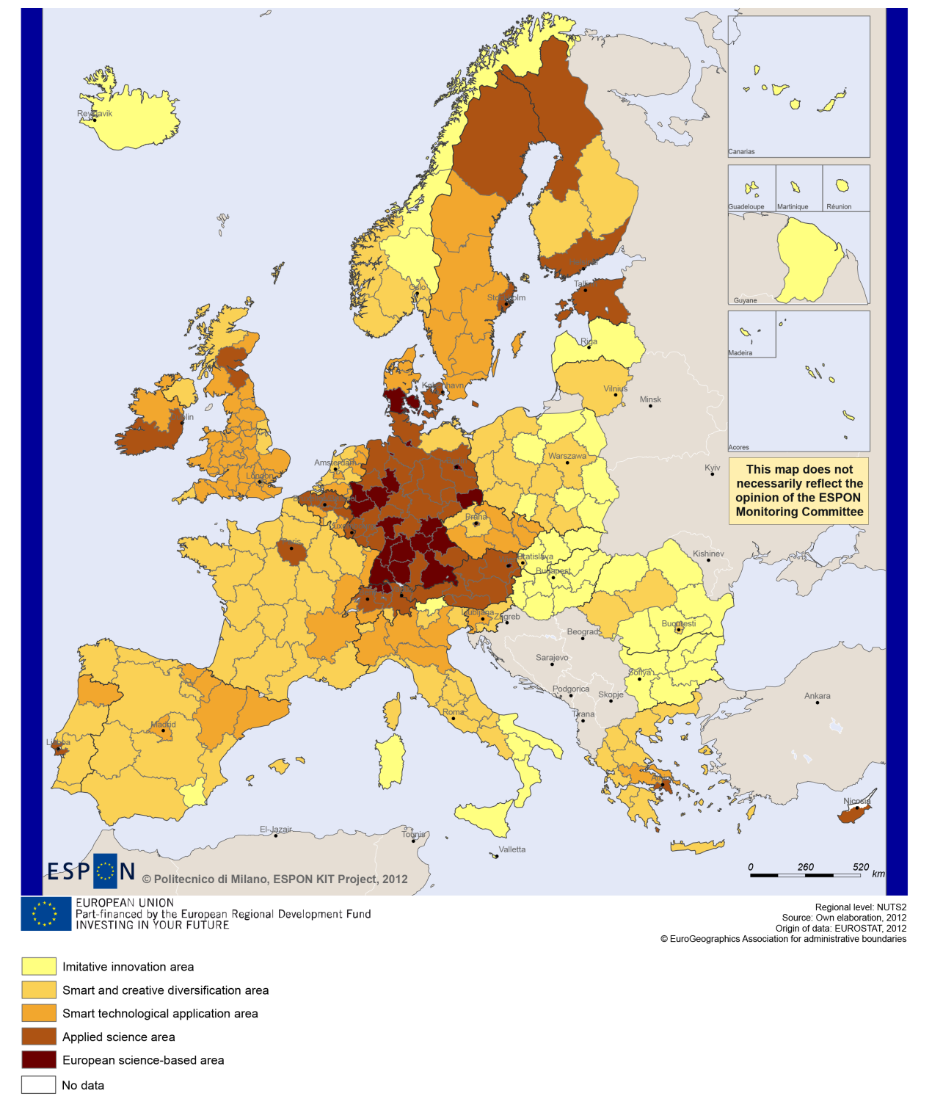

MAP 2 – Territorial impact on fossil fuel consumption of Directive on the promotion of clean and energy-efficient road transport vehicles (ESPON ARTS project) TNC North Sea

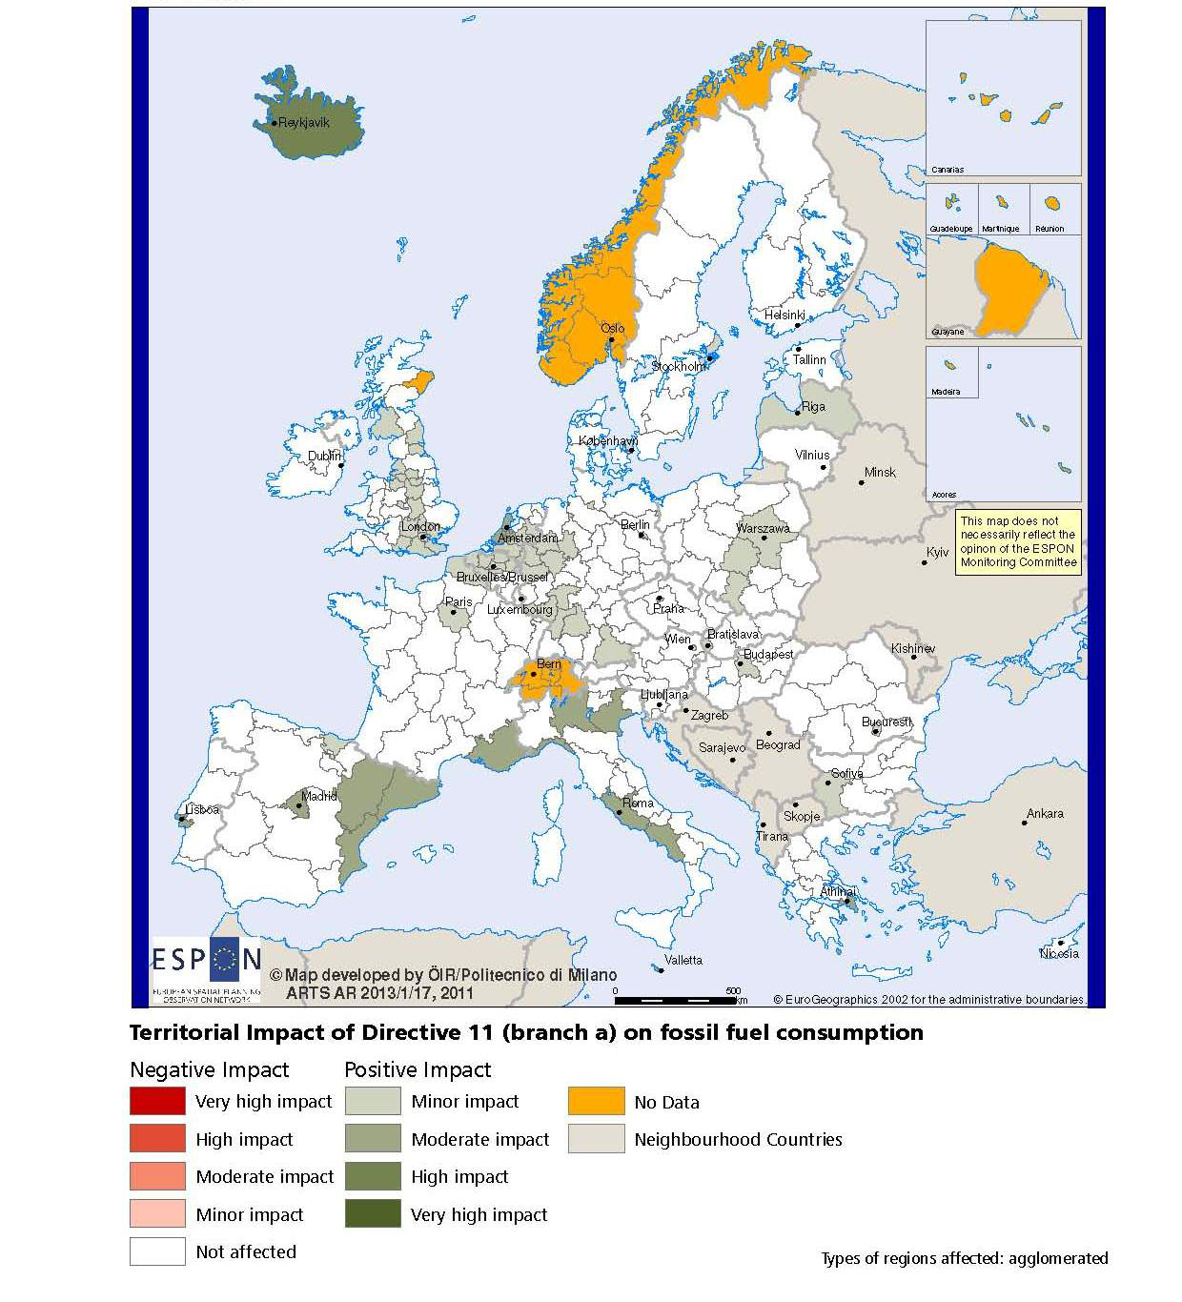

MAP 3 – Combined adaptive capacity to climate change (ESPON CLIMATE project) for the TNC North Sea
“Adaptive capacity (adaptability)” to climate change indicates the ability or potential of a system to respond successfully to climate change and variability, and includes adjustments in behaviour, resources and technologies.
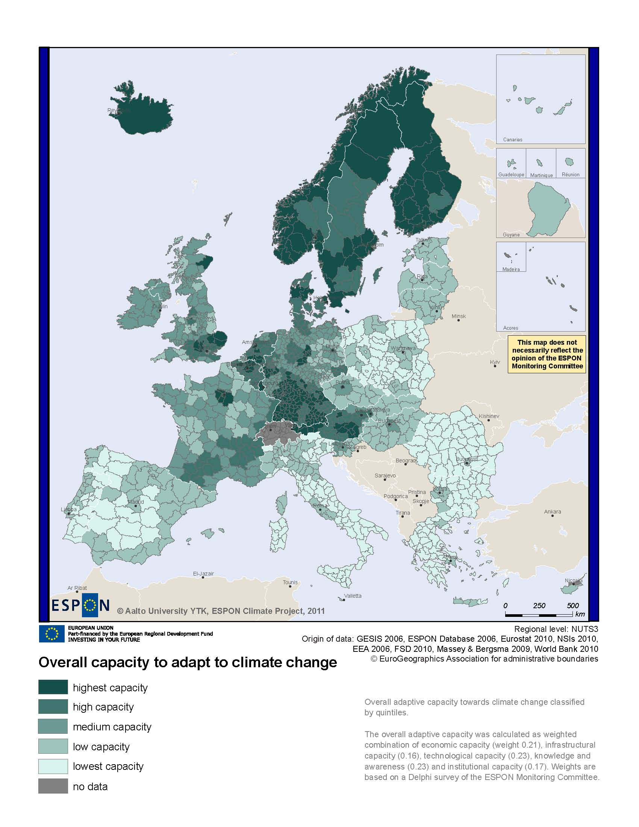
MAP 4 – Change in Labour Force 2005-2050 (ESPON DEMIFER project) for the TNC North Sea

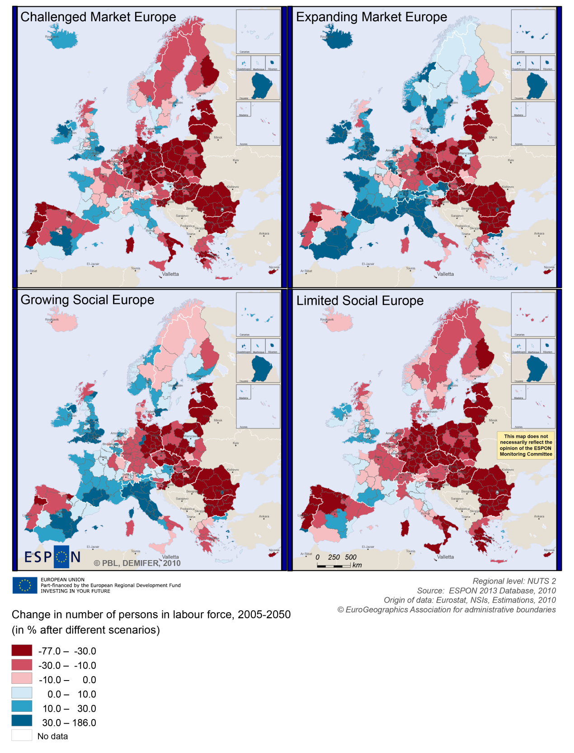

MAP 5 – Employment rate 2010 within the TNC North Sea

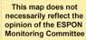
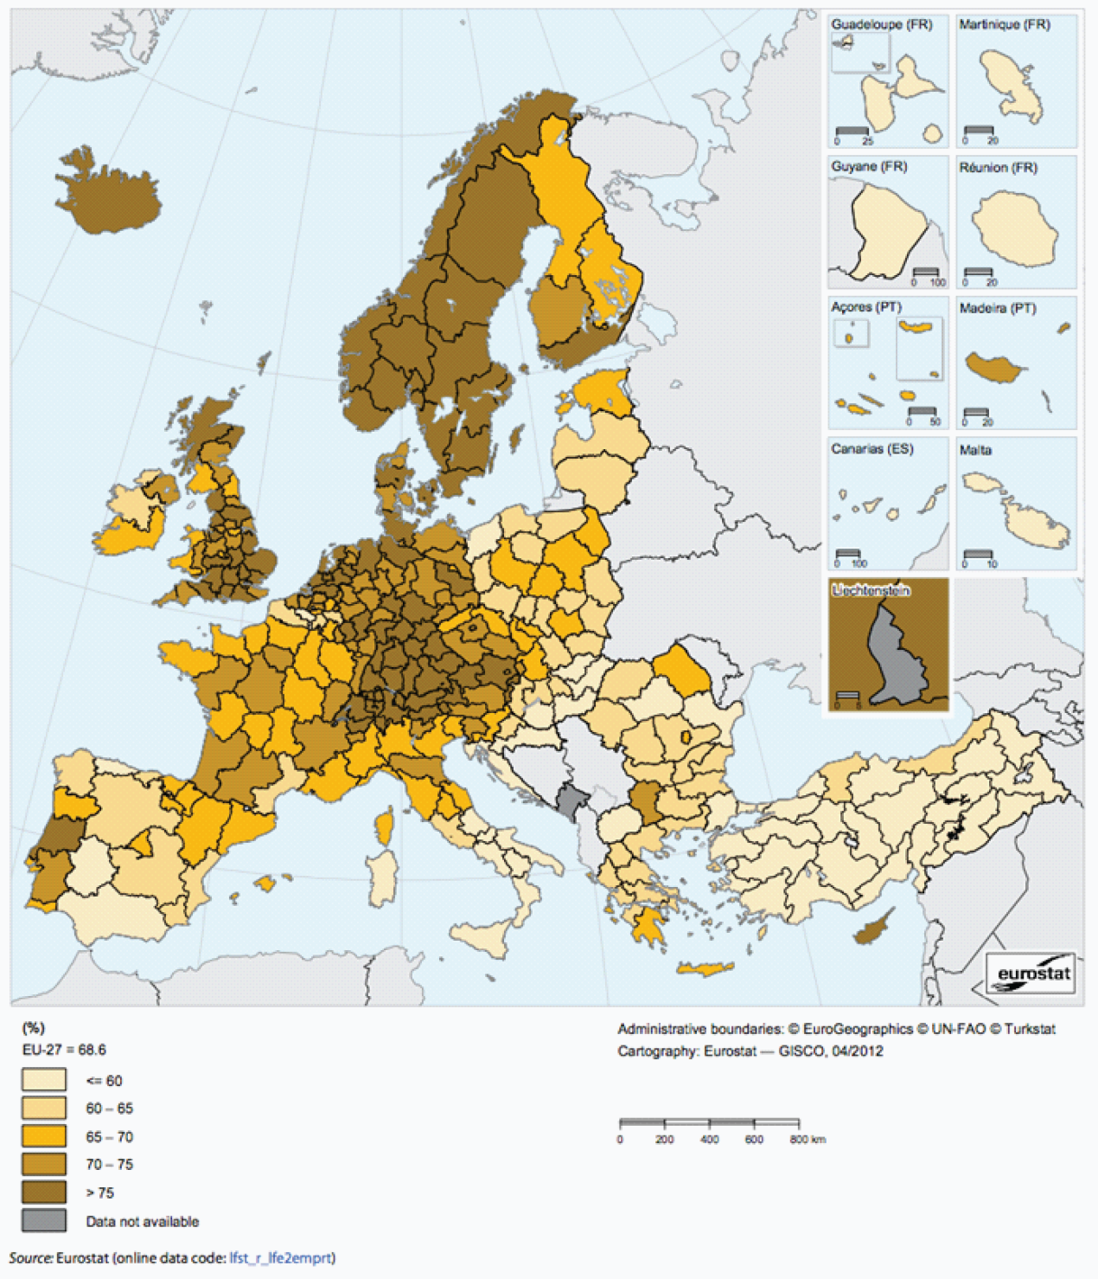

Territorial factors of interest for the programme area
Territorial cooperation programmes can make a difference for the future development of cross-border and transnational territories in Europe. Some of the factors can be analysed by European wide data sets and using some studies having specific maps, figures and tables concerning the areas of the cooperation region.
Besides a wide range of standard indicators frequently used in the context of European regional policies, ESPON has established various indicators which focus more on the territorial dimension. These indicators provide among others information on the development preconditions of an area. Two standard indicators in this field are rural-urban settings and accessibility.
Some of Europe’s most important metropolitan areas are either part of the North Sea Region programme area or just neighbouring the area thus being of influence. Among them are e.g. London, Amsterdam, Rotterdam and Copenhagen. Furthermore, the programme area comprises a range of other metropolitan areas and secondary growth poles. The below map shows that a large share of the region consists of urban areas or intermediate areas close to a city. Rural areas are mainly to be found in the Nordic part of the programme area and there the rural areas often even are characterised as remote.
The urban areas of the region host furthermore, a number of important worldwide transport hubs and serve as global gateways for larger parts of Europe. Also when it comes to multimodal accessibility the possibility for one-day business trips within the European urban network, most of the regions urban centres are well placed. As already mentioned in the operational programme for the 2007-2013 period “The position of the North Sea Region in Europe in the transport sector is unique, with the majority of goods passing through the region on their way to other parts of Europe. Accessibility, both of goods and persons, including communications, is an important facet in promoting and maintaining economic growth and employment. “
At the same time, the programme area comprises also some regions with the lowest accessibility values in Europe. In particular the remote rural areas in northern Norway are challenged in terms of multimodal accessibility.
- With regard to geographic specificities, the programme areas is clearly characterised by coastal areas and islands, but it comprises also a large share of mountain areas in particular in Scotland and Norway. Many of these mountain areas are at the same time characterised as sparsely populated.
In particular the coastal character comes with advantages and challenges. Although it does not come with a specific economic structure, it appears that a significant proportion of areas have high residential attractiveness. Furthermore, many coastal areas are also characterised by relatively high levels of biodiversity and protected areas. Furthermore, coastal ecosystems provide not only food but habitats for diverse economic-valuable and other species. At the same time the high population density and economic activities along some parts of the cost pose also considerable environmental challenges.
Last but not least, it has to be noted that coastal areas and islands are often particularly vulnerable to climate change.

MAP 6 – Urban-rural typology of NUTS3 regions including remoteness (DG Regio) for the TNC North Sea

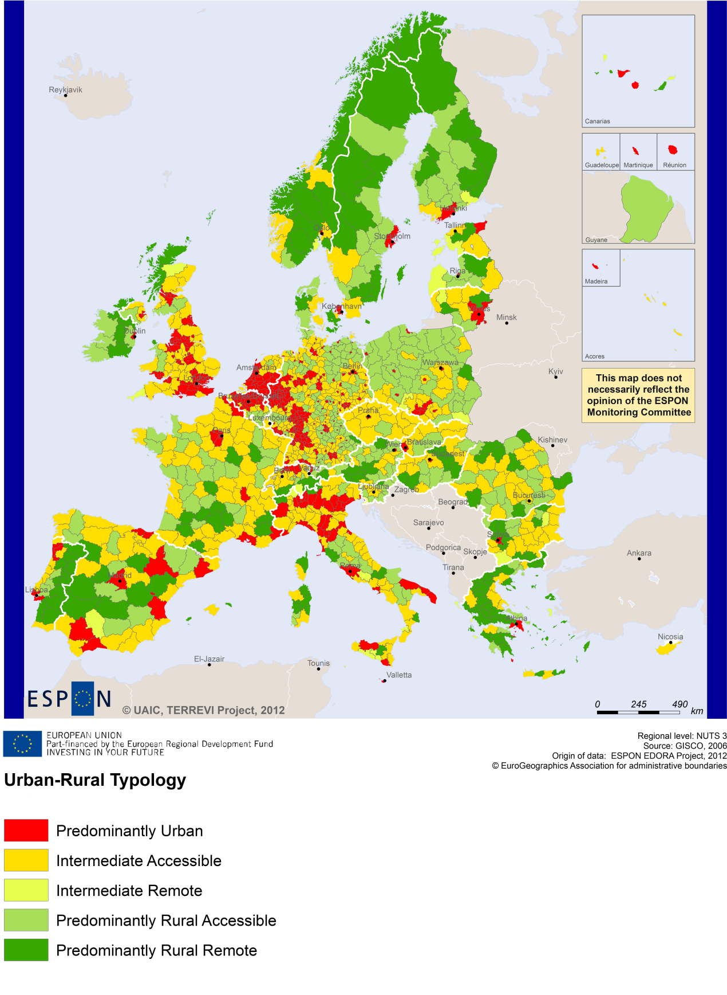

MAP 7 – Multimodal accessibilty (ESPON Accessibility Update) for the TNC North Sea
“Potential Accessibility Multimodal” scores accessibility of NUTS 3 regions by road, rail and air relative to the European average in an Accessibility Index.
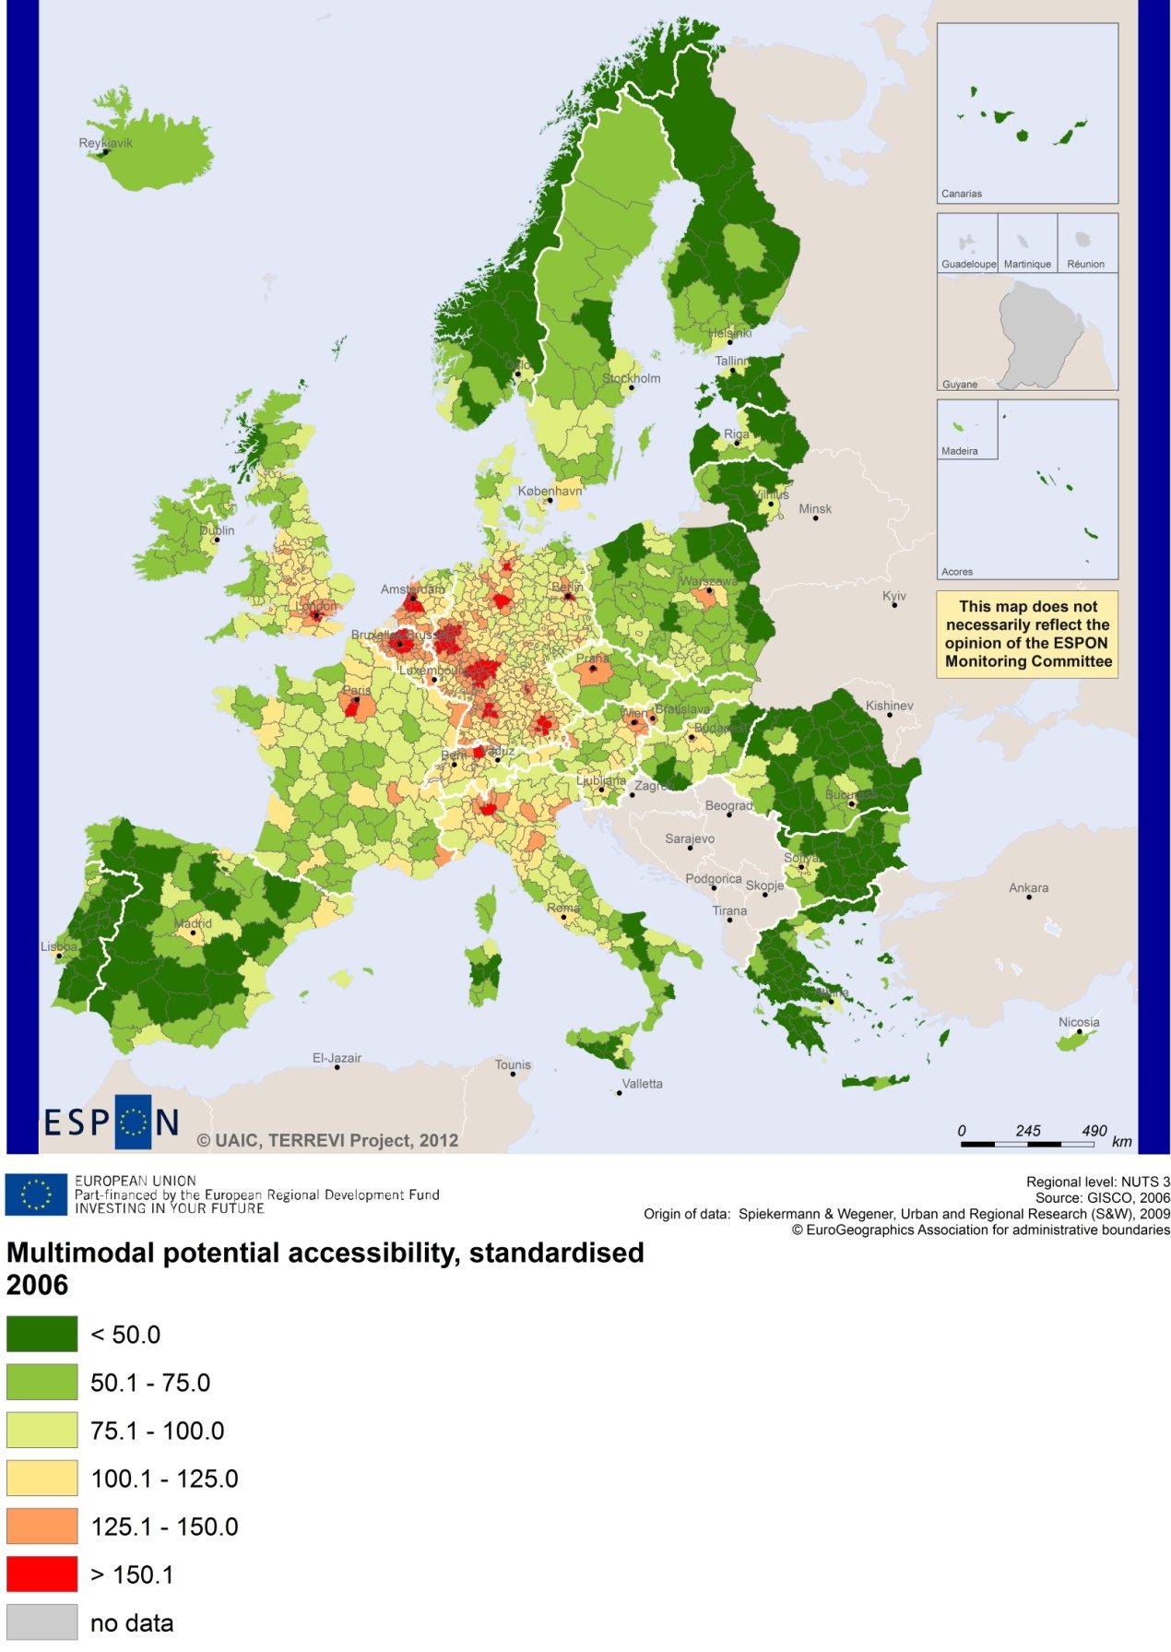

Recommended ESPON reading
ESPON provides an essential underpinning for translating into practice the calls for integrated and place-based approaches to economic development, when analysing a programme area or deciding about future programme priorities. ESPON has published a wide range of exciting reports providing valuable territorial evidence for future territorial cooperation initiatives.
The table below shows examples of relevant projects for the Cooperation Region. However, you have to study other ESPON reports as well in order to capitalise fully on the European information available for the transnational programming.
ESPON study | Topic | Content
TRANSMEC | European cooperation | It develops a method providing guidance on how ESPON results can add value to support territorial cooperation programmes (see map 27 and from map 36 to 39 on potential accessibility indicators). The method is applied for the Northwest-Europe cooperation area.
SGPTD | Growth poles | It provides evidence on European secondary cities, their performance and functional roles in different parts of Europe, and the potential policy intervention affecting their performance (see from figure 2 to 2.12). The report includes a case study on Leeds, in the UK (annex of the Scientific Report).
ATTREG | Attractiveness | It provides a better understanding of the contribution of European regions’ and cities’ attractiveness to economic performance and it identifies the key ingredients of attractiveness in different types of territories. The report includes a case study on the island of Bornholm, in Denmark (see Annex 4/2).
GEOSPECS | Specific types of territories | It provides evidence on the strength, weaknesses and development opportunities of specific types of territories and regions (e.g. border areas, highly or sparsely populated areas). The project focuses on the Belgian coast as a case study.
ReRisk | Energy | It focuses on opportunities to support competitive and clean energy supplies for regions in Europe and to generate and strengthen sustainable energy sources. It includes a case study of the Island of Samsø, in Denmark.
TERCO | Territorial cooperation | It provides an assessment of the adequacy of existing territorial cooperation areas for meeting current challenges of territorial development and a proposal of potentially meaningful new cooperation areas throughout Europe. The project analyses the region of “Scotland-Sweden-Norway” as a case study (see 2.3.5 in the Scientific Report).
KIT | Innovation | It takes into account the current state, patterns and potentials of regions with respect to the knowledge and innovation economy and identifies new development opportunities through innovation for Europe and its territories (see from map 3.1.1 to 4.4.1). The case studies include ICT in Cambridge (volume 2 of the annex of the scientific report), and TV and digital media in Cardiff (volume 3 of the annex of the scientific report).
RISE | Integrated strategies | It shows how monitoring and evaluation indicators and methodologies can be used to enhance the development of Regional Integrated Strategies. The case studies include Randstad, in the Netherlands, and Zealand, in Denmark.
TPM | Territorial performance | The project analysis how territorial impacts of macro challenges translate at the regional level and how to best deal with these challenges. The project provides a regional case study on the Flanders, in Belgium (see the Annex “Vlaanderen”).
EUROISLANDS | Islands | It gives evidence on the divergence of island's situation and on existing policy measures for the islands. The project includes a case study on Samsø.
Furthermore, some of overall ESPON products of particular interest for territorial cooperation are:
- ESPON Synthesis report “new evidence on smart, sustainable and inclusive territories” provides an easy to read overview on ESPON results available.
- ESPON Territorial Observations is a publication series, which on a few pages presents policy relevant findings deriving from latest ESPON research.
- ESPON 2013 Database provides regional information provided by ESPON projects and EUROSTAT.
- ESPON Hyperaltas allows comparing and analysing a region’s relative position at European, national and local scale for a wide range of criteria.
- ESPON MapFinder provides access to the most relevant ESPON maps resulting from ESPON projects and reports.
- ESPON Typologies provides nine regional typologies for additional analysis of regional data to be considered in the European context.
All ESPON reports and tools are freely available at
www.espon.eu

The ESPON 2013 Programme is part-financed by the European Regional Development Fund, the EU Member States and the Partner States Iceland, Liechtenstein, Norway and Switzerland. It shall support policy development in relation to the aim of territorial cohesion and a harmonious development of the European territory.

