Baltic Sea
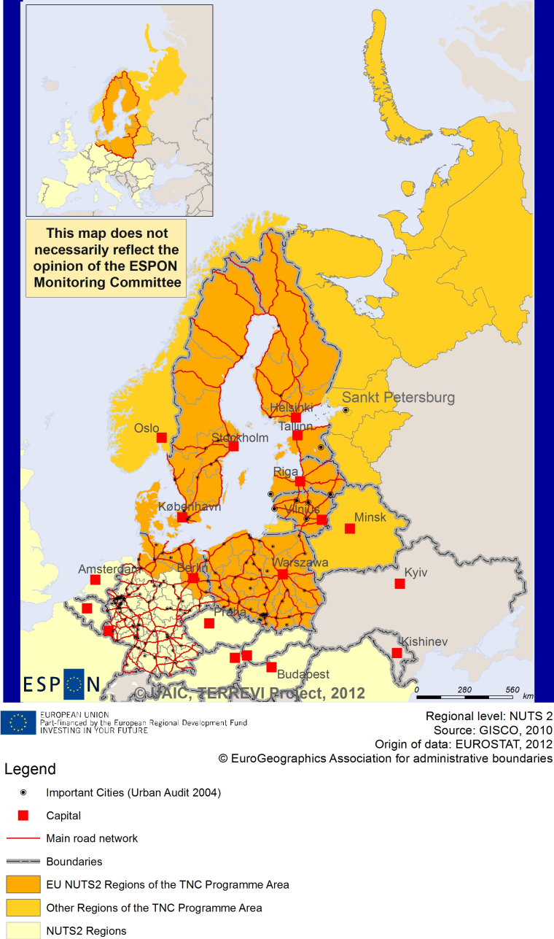

ESPON Project TERREVI
November 2012

Introduction
ESPON supports policy development in relation to the aim of territorial cohesion and a harmonious development of the European territory. It provides comparable information, evidence, analysis, and scenarios on territorial dynamics, which reveal territorial capitals and development potentials of regions and larger territories. Considering the programme area in its European context adds an important new perspective that can help shaping the programming and the places of implementing projects.
The ESPON TERREVI project focuses on producing evidence for Structural Funds programmes with the aim to support the development of the programmes to be carried out in the 2014-2020 period.
One milestone of this work consists in presenting selected ESPON research pieces in easy-to-understand factsheets for all territorial cooperation programme areas. The aim is to provide the reader with preliminary insight on types of territorial evidence ESPON holds at hand with regard to the possible investment priorities of future programmes. The factsheets certainly only give a first glimpse rather than fully present the work of the large number of ESPON projects that are currently underway. Likewise, each programme area includes diverse development potentials and challenges, which needs targeted information search. However, hopefully this factsheet will contain information, benchmarking the programme area in its larger, territorial context, that is of interest and help to better understand the programme area and to navigate within the richness of ESPON material available.
In addition to the programme factsheets there will be a number of specific programme case studies illustrating how ESPON material can be used to support the development of future programmes e.g. by giving a comparative European dimension to the envisaged SWOTs. These case studies will be carried out in early 2013
This factsheet is structured in three main parts. The first part presents a selection of indicators that help comparing the situation of the programme area in question with the European average, the average for all programme areas as well as the situation in the countries involved. The second part briefly presents the territorial factors of interest for the programme area. The final part offers guidance on the further use of ESPON results and tools. This is intended as an electronic publication so map quality is generally high to allow users to zoom into specific territories.
This factsheet does not necessarily reflect the opinion of the ESPON Monitoring Committee.

Europe 2020
Europe, with its member states and their regions, is more exposed to global shocks and international competition than at any time before. As the world becomes more interdependent this trend will continue and shape policy thinking across sectors, borders and geographical scales. At the same time, Europe is characterised by a large territorial diversity meaning that global developments can imply rather different development possibilities and challenges for different European regions and cities.
The differences are partly defined by major geographical structures such as urban systems, access and connectivity, the geographical specificity or population density. At the same time, the differences are also spelled out in the larger development trends that affect an area and the way and degree to which it is affected.
The data, indicators and territorial evidence provided by ESPON provides insight on both the main structures and larger territorial trends. The fine art is to identify what can actually be influenced by policy-making and, in particular, by place-based policy and territorial cooperation related to your programme area.
This chapter provides a selection of ESPON data related to Europe 2020 objectives of smart, sustainable and inclusive growth, giving also hints as regards the main thematic objectives envisaged in the draft regulations for the next period of EU Cohesion Policy. The Europe 2020 Strategy aims to enhance smart, sustainable and inclusive growth. This strategy has clear territorial dimensions. However, achieving these goals is challenging in the crisis-driven times. Furthermore, the economic disparities are growing as economic trends and the crisis have various impacts on different parts of Europe.
In the following the traffic light for each indicator represents how your programme territory compares to wider European medians where green = your programme area performs better for that indicator, yellow = similar, and red = worse.
The traffic lights below were created in order to graphically represent the situation of each analysed TNC Area compared to the one of the EU-27+4 space. The median value, calculated depending on the values registered for every NUTS 2/NUTS 3 region composing the programme area was used as the central value indicator. The median of the programme area was compared to the one computed for EU-27+4 territory.
EU 27+4 in traffic lights means the EU Member States as well as Iceland, Liechtenstein, Norway and Switzerland – the ESPON space.

Smart, Sustainable and Inclusive growth
Smart growth refers to developing an economy based on knowledge and innovation. In the framework of the Europe 2020 Strategy it means improving the EU's performance in education, research/innovation and digital society.
Sustainable growth refers to promoting a more resource efficient, greener and more competitive economy. Within the Europe 2020 Strategy it means e.g. building a more competitive low-carbon economy that makes efficient, sustainable use of resources, protecting the environment, reducing emissions and preventing biodiversity loss, capitalising on Europe's leadership in developing new green technologies and production methods, and introducing efficient smart electricity grids. In the framework of the Europe 2020 Strategy it means focus on competitiveness, resource efficiency, climate change and biodiversity.
Inclusive growth refers to fostering a high-employment economy delivering social and territorial cohesion. Within the Europe 2020 Strategy it means raising Europe’s employment rate, helping people of all ages anticipate and manage change through investment in skills & training, modernising labour markets and welfare systems, and ensuring the benefits of growth reach all parts of the EU. In short the key factors are employment and avoiding risk of poverty and social exclusion.
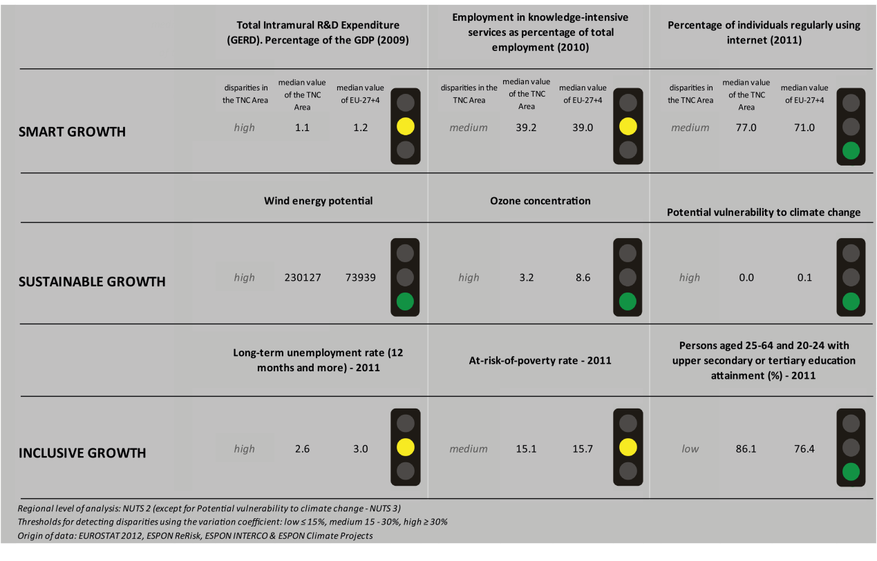
The smart growth indicators on ‘R&D expenditure’ and ‘employment in knowledge-intensive services’ are similar in the Baltic Sea TNC area and the EU27+4. Looking at the traffic lights, the TNC area however has a higher amount of individuals regularly using the internet than the EU27+4 median.
Map 1 shows high disparities within the region with regards to innovation. In fact, the German parts as well as the Swedish and Finnish areas (especially in the north) are qualified as ‘smart technological application areas’ and ‘applied science areas’. The area even includes some of the few ‘European science-based areas’. On the other hand, the Eastern European and Baltic parts of the TNC area are qualified as areas with lower innovation intensity.
The Baltic Sea cooperation area’s sustainable growth indicators ‘wind energy potential’, ‘ozone concentration’ and ‘potential vulnerability to climate change’ all show more positive values than for the EU27+4. However, the disparities within the TNC area are high for all three indicators. This can also be seen from Map 3 which shows that the Scandinavian countries and Germany have a higher capacity to adapt to climate change than the Eastern European and Baltic parts of the TNC area.
The Directive on the promotion of clean and energy-efficient road transport vehicles has no impact at all on the fossil fuel consumption in most parts of the Baltic Sea TNC area, with the exception of some regions in Poland and Latvia which experience a minor impact.
The inclusive growth indictor of ‘persons aged 25-64 and 20-24 with upper secondary or tertiary education attainment’ is more positive in the Baltic Sea TNC area than the EU27+4. The at-risk-of-poverty and the long-term unemployment rates of the TNC area are comparable to those in the EU27+4 in total. The diversity within the TNC area with regards to the employment rate is high, however. In fact, Map 3 shows that the employment rate in the Scandinavian countries and Germany is high. The employment rate in the Baltic and Central and Eastern European parts is however lower. The employment rate in Latvia, Lithuania and most parts of Poland amount to only around and under 60%.
All four DEMIFER scenarios predict a rather negative picture for almost the entire Baltic Sea TNC area, except of the scenario ‘expanding market Europe’ in which case the change in labour force has a positive outcome in the Scandinavian countries. In the scenario ‘growing social Europe’ the values are positive for the south of Sweden, Norway and Finland and the central part of Poland.
MAP 1 – Territorial Patterns of Innovation (ESPON KIT project) for the TNC Baltic Sea

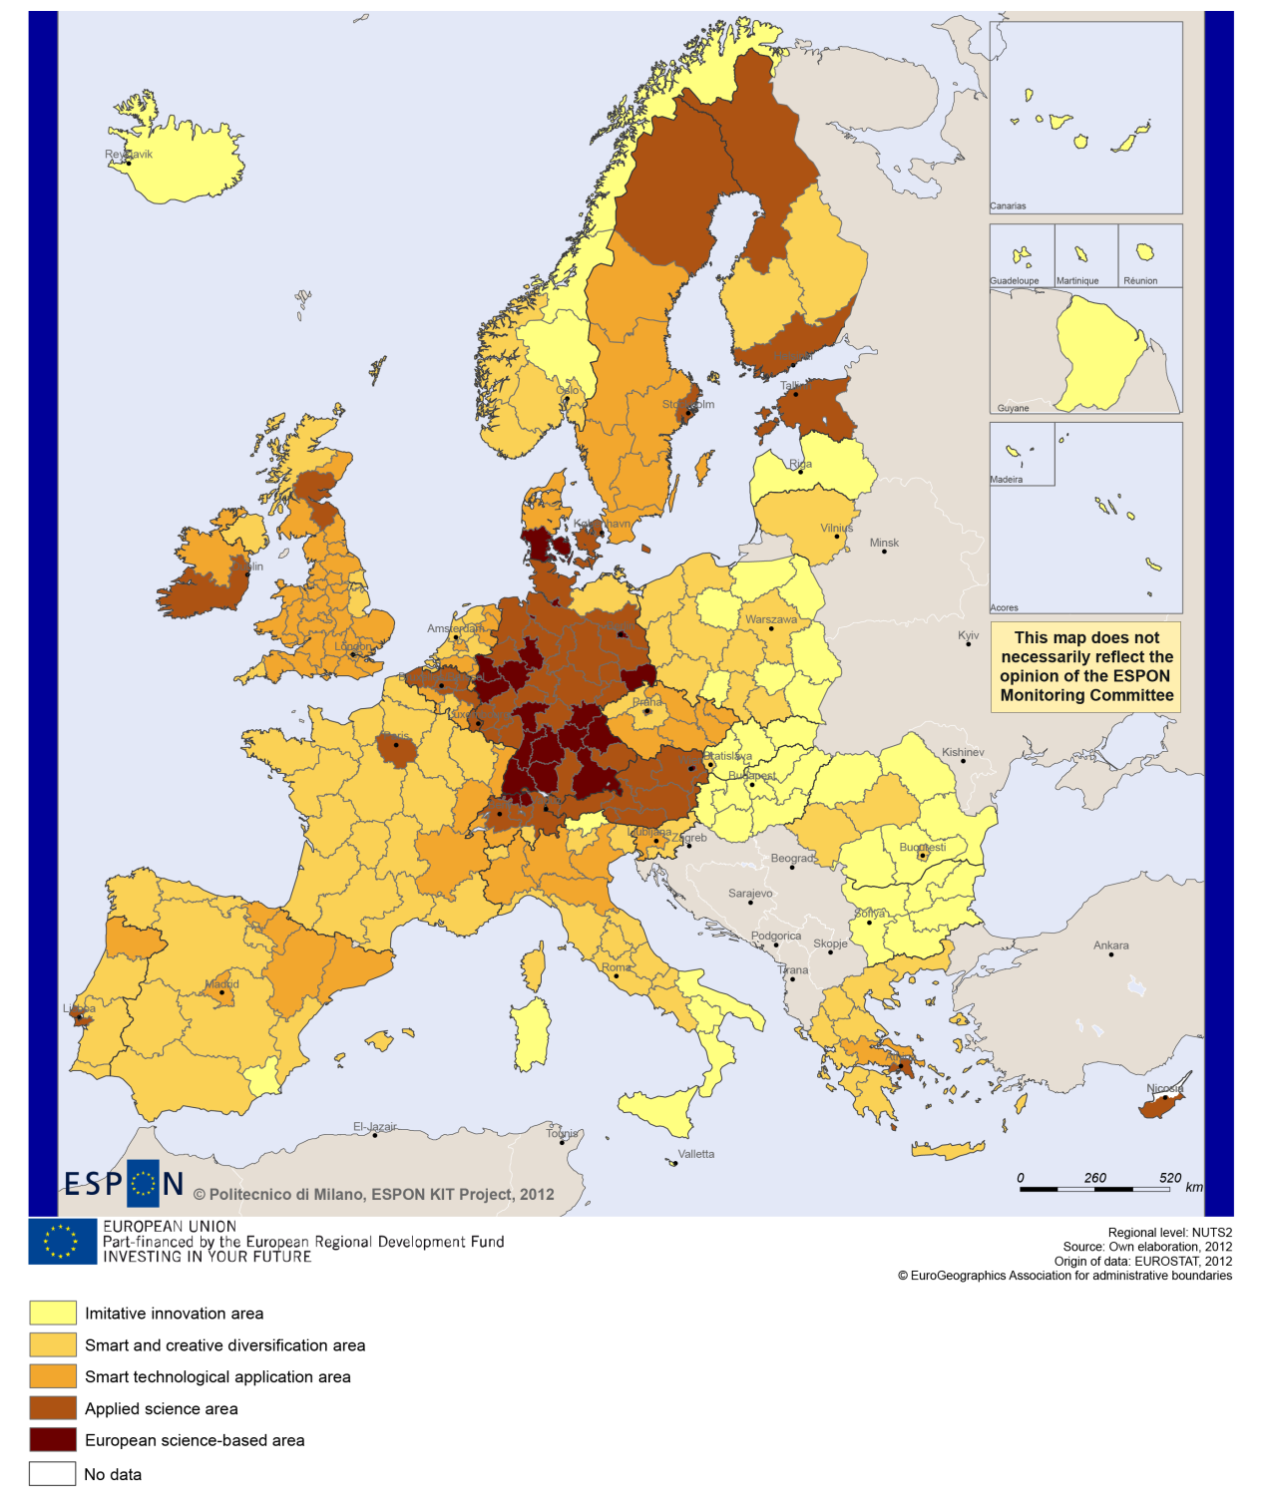

MAP 2 – Territorial impact on fossil fuel consumption of Directive on the promotion of clean and energy-efficient road transport vehicles (ESPON ARTS project) TNC Baltic Sea

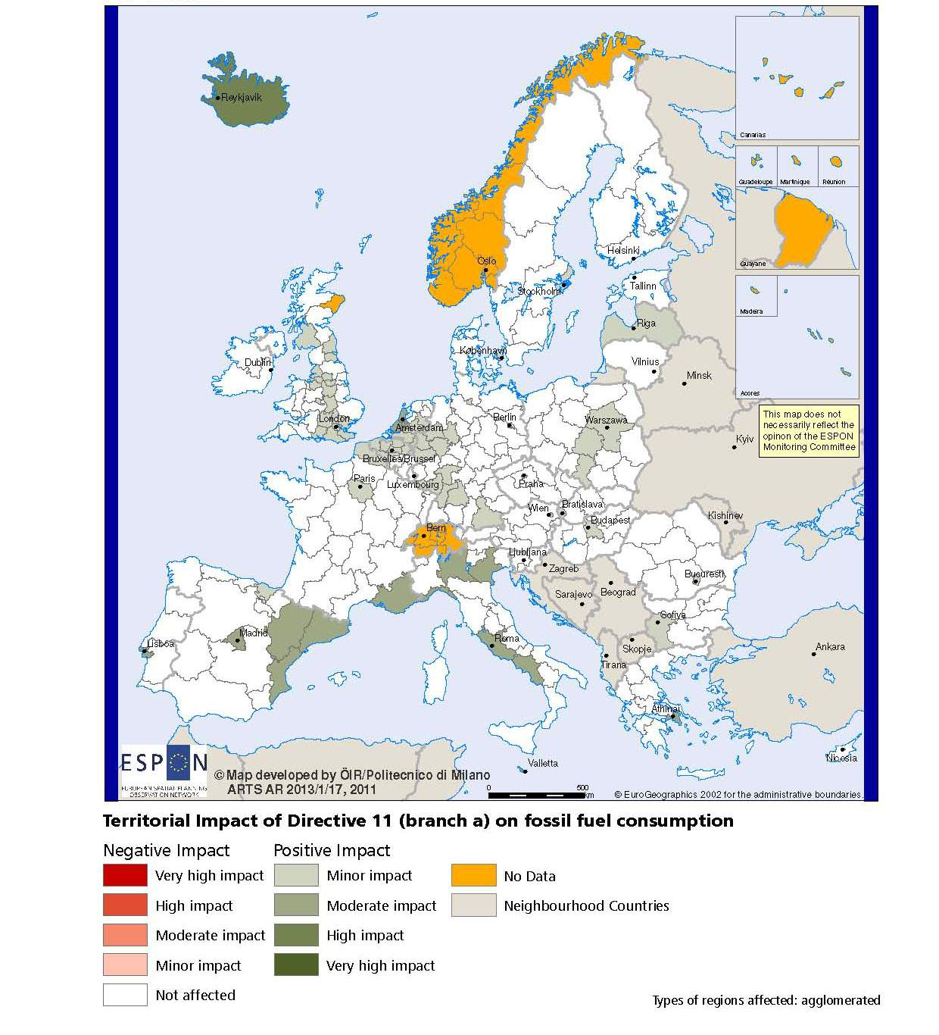

MAP 3 – Combined adaptive capacity to climate change (ESPON CLIMATE project) for the TNC Baltic Sea
“Adaptive capacity (adaptability)” to climate change indicates the ability or potential of a system to respond successfully to climate change and variability, and includes adjustments in behaviour, resources and technologies.
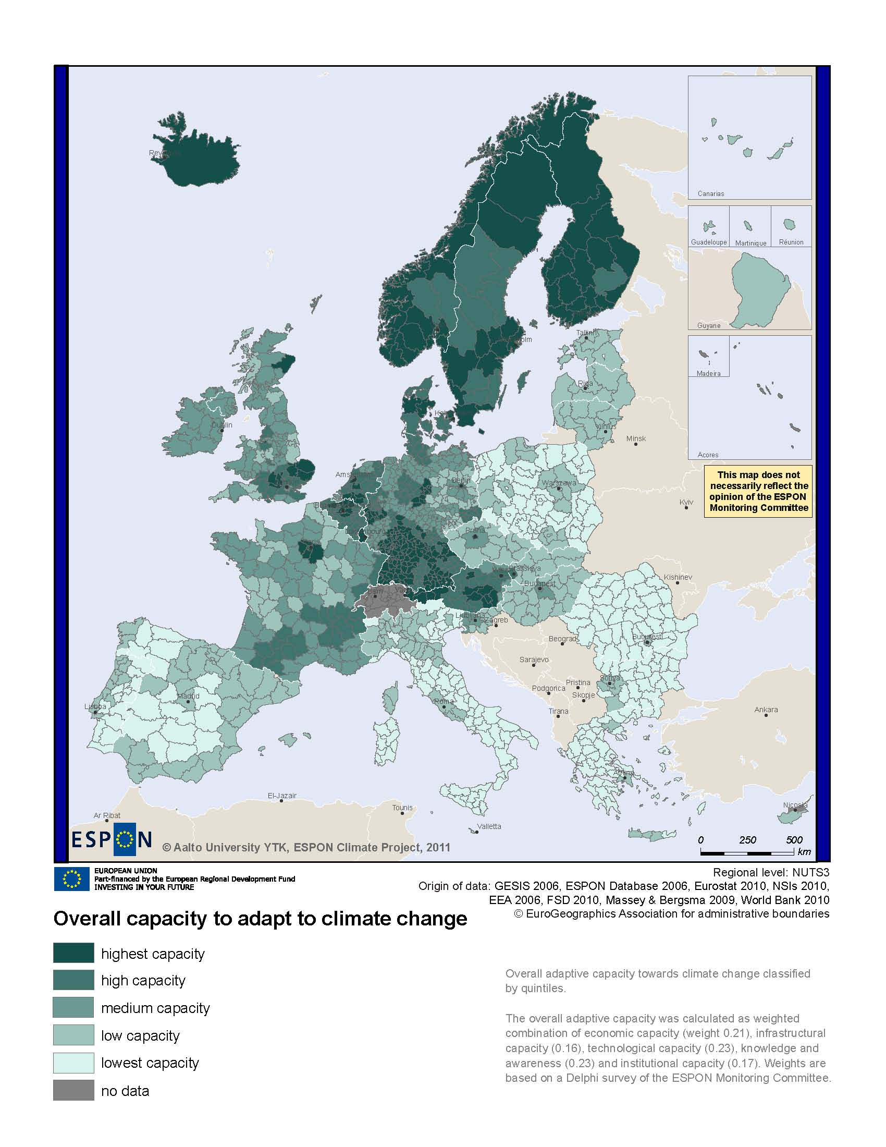
MAP 4 – Change in Labour Force 2005-2050 (ESPON DEMIFER project) for the TNC Baltic Sea

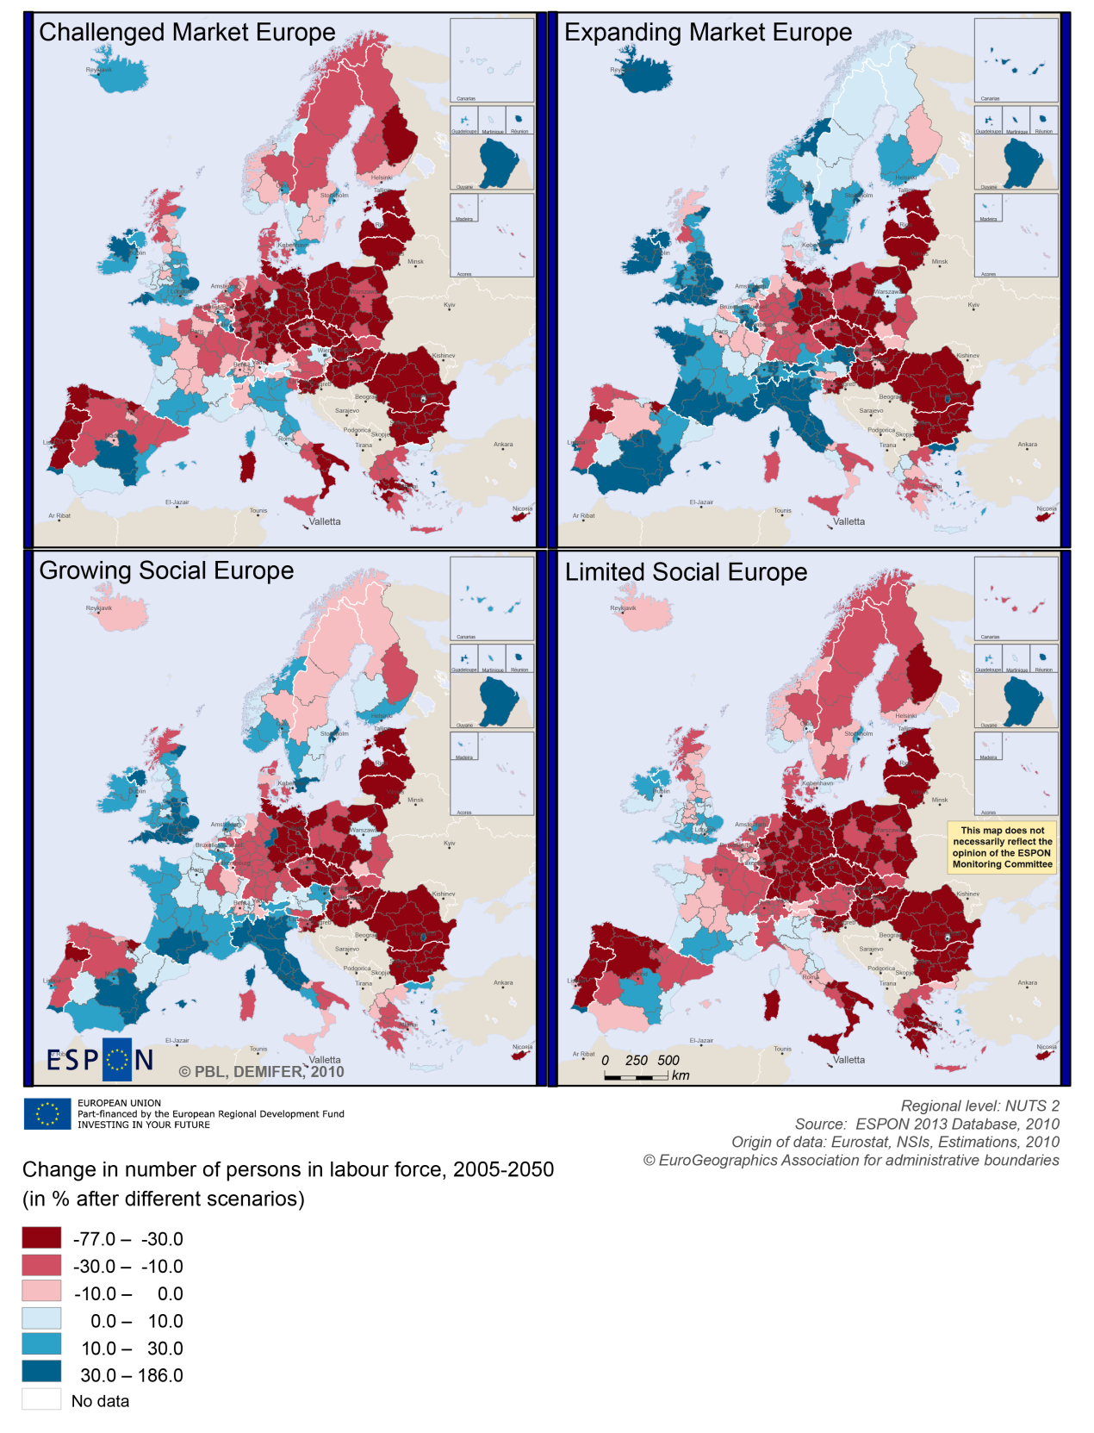

MAP 5 – Employment rate 2010 within the TNC Baltic Sea

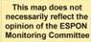
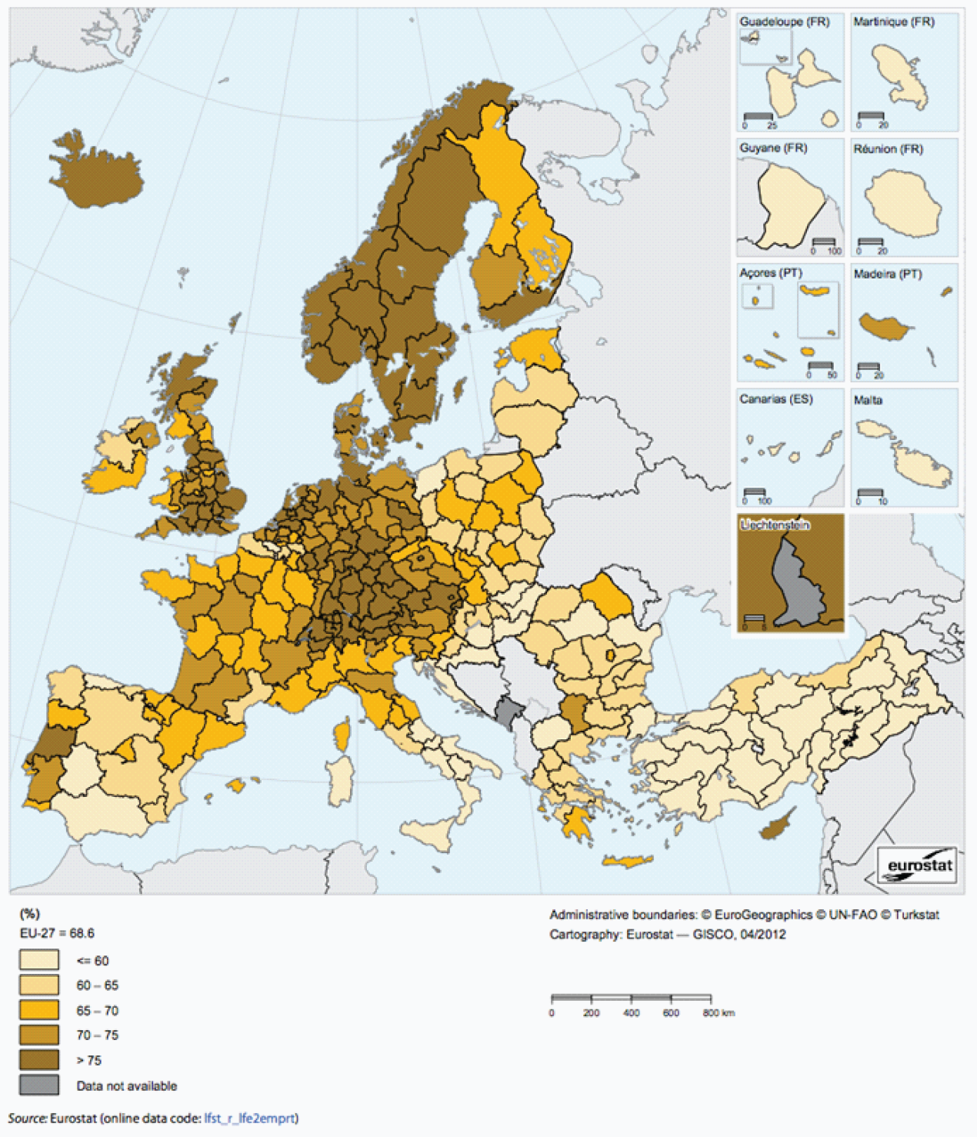

Territorial factors of interest for the programme area
Territorial cooperation programmes can make a difference for the future development of cross-border and transnational territories in Europe. Some of the factors can be analysed by European wide data sets and using some studies having specific maps, figures and tables concerning the areas of the cooperation region.
Besides a wide range of standard indicators frequently used in the context of European regional policies, ESPON has established various indicators which focus more on the territorial dimension. These indicators provide among others information on the development preconditions of an area. Two standard indicators in this field are rural-urban settings and accessibility.
The Baltic Sea Region programme area comprises a number of European metropolitan areas such as Berlin, Copenhagen, Oslo, Stockholm, Helsinki, St. Petersburg, Tallinn, Riga, Vilnius and Warsaw and also a wide range of secondary growth poles.
Despite the large number of urban areas, most of the programme area is characterised as intermediate or rural areas – in a European perspective. In the south of the Baltic Sea the urban settlement patterns are denser and most intermediate and rural areas are considered as being in close proximity to a city. In the Nordic Countries and to some degree also in Estonia, Latvia and Lithuania the rural regions are often characterised as remote. The map illustrates the territorial differences within the programme area, basically showing a divide between the more densely populated areas and the more remote areas in the North.
Whereas the metropolitan areas in particular Copenhagen, Hamburg and Berlin have comparably good multimodal accessibility, large parts of the programme have accessibility values below European average. Also possibilities for one-day business trips within the European city network are mainly limited to the capital cities plus the larger urban areas in Poland and the German part of the programme area, as well as Malmö and Gothenburg in Sweden and St. Petersburg. Good accessibility is centred towards large urban agglomerations and major international airports or major train stations whereas other parts of the programme area have below accessibility values below European average. Many remote regions of the programme area have considerably less favourable accessibility and some even the lowest accessibility figures in Europe.
With regard to geographic specificities, the programme areas comprises certainly a large amount of coastal areas, a number of islands, and most of the sparsely populated areas in Europe, some of them being also mountainous areas. Accordingly a substantial part of the programme area is to be considered as territories with geographic specificities.
The territorial specificities come with advantages and challenges. Although they do not come with a specific economic structure, it appears that a significant proportion of mountain and coastal areas as well as islands have high residential attractiveness. Many mountain and coastal areas are also characterised by relatively high levels of biodiversity and protected areas. Furthermore, coastal ecosystems provide not only food but habitats for diverse economic-valuable and other species.
Last but not least, it has to be noted that coastal areas and islands are often particularly vulnerable to climate change.

MAP 6 – Urban-rural typology of NUTS3 regions including remoteness (DG Regio) for the TNC Baltic Sea

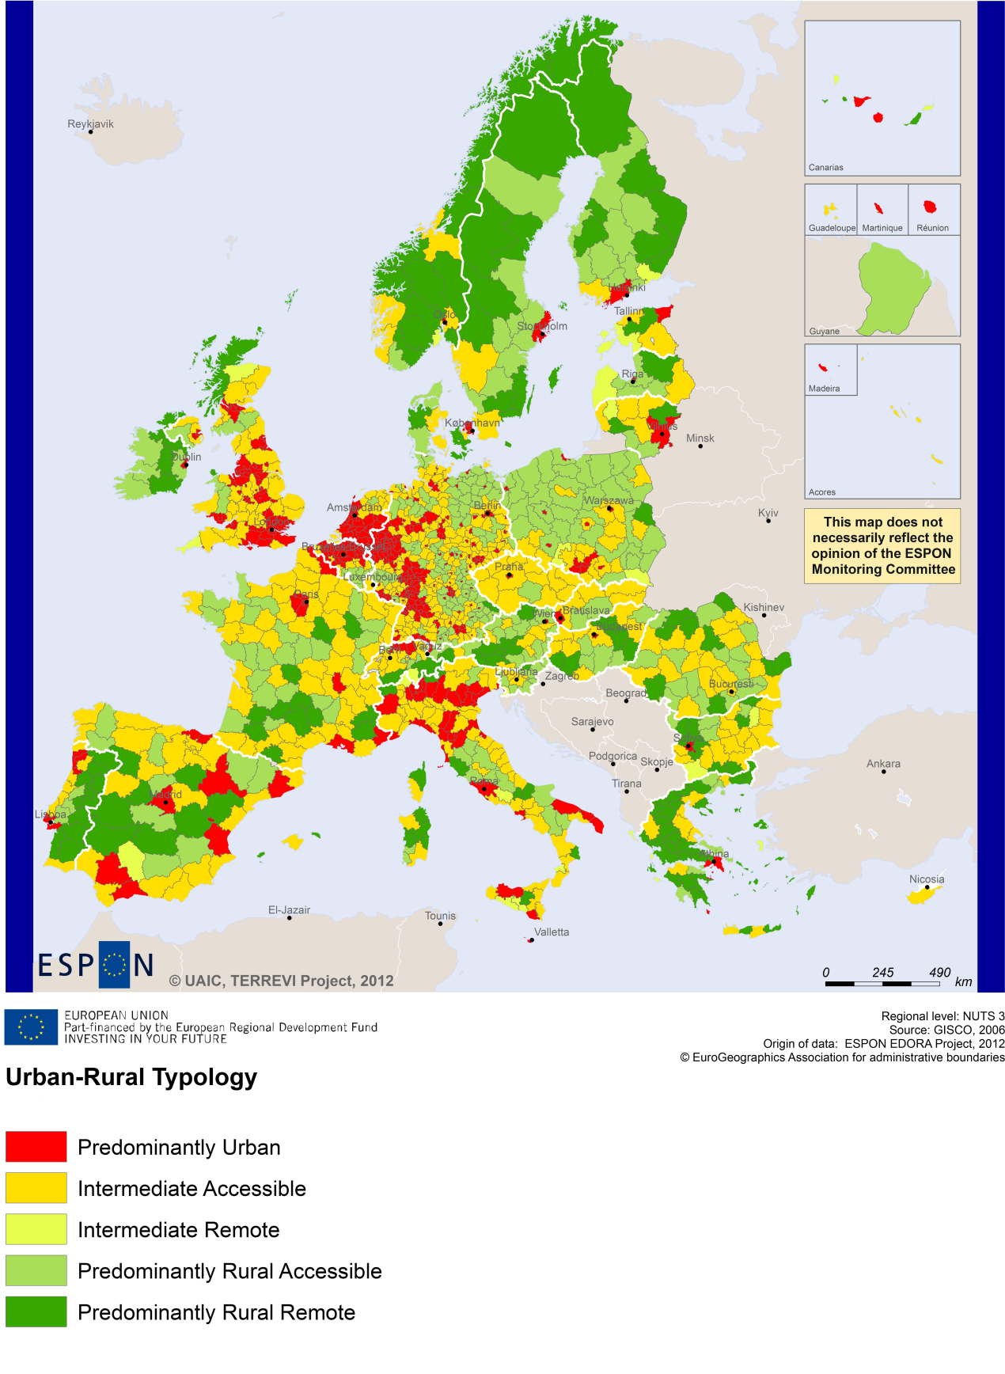

MAP 7 – Multimodal accessibilty (ESPON Accessibility Update) for the TNC Baltic Sea
“Potential Accessibility Multimodal” scores accessibility of NUTS 3 regions by road, rail and air relative to the European average in an Accessibility Index.
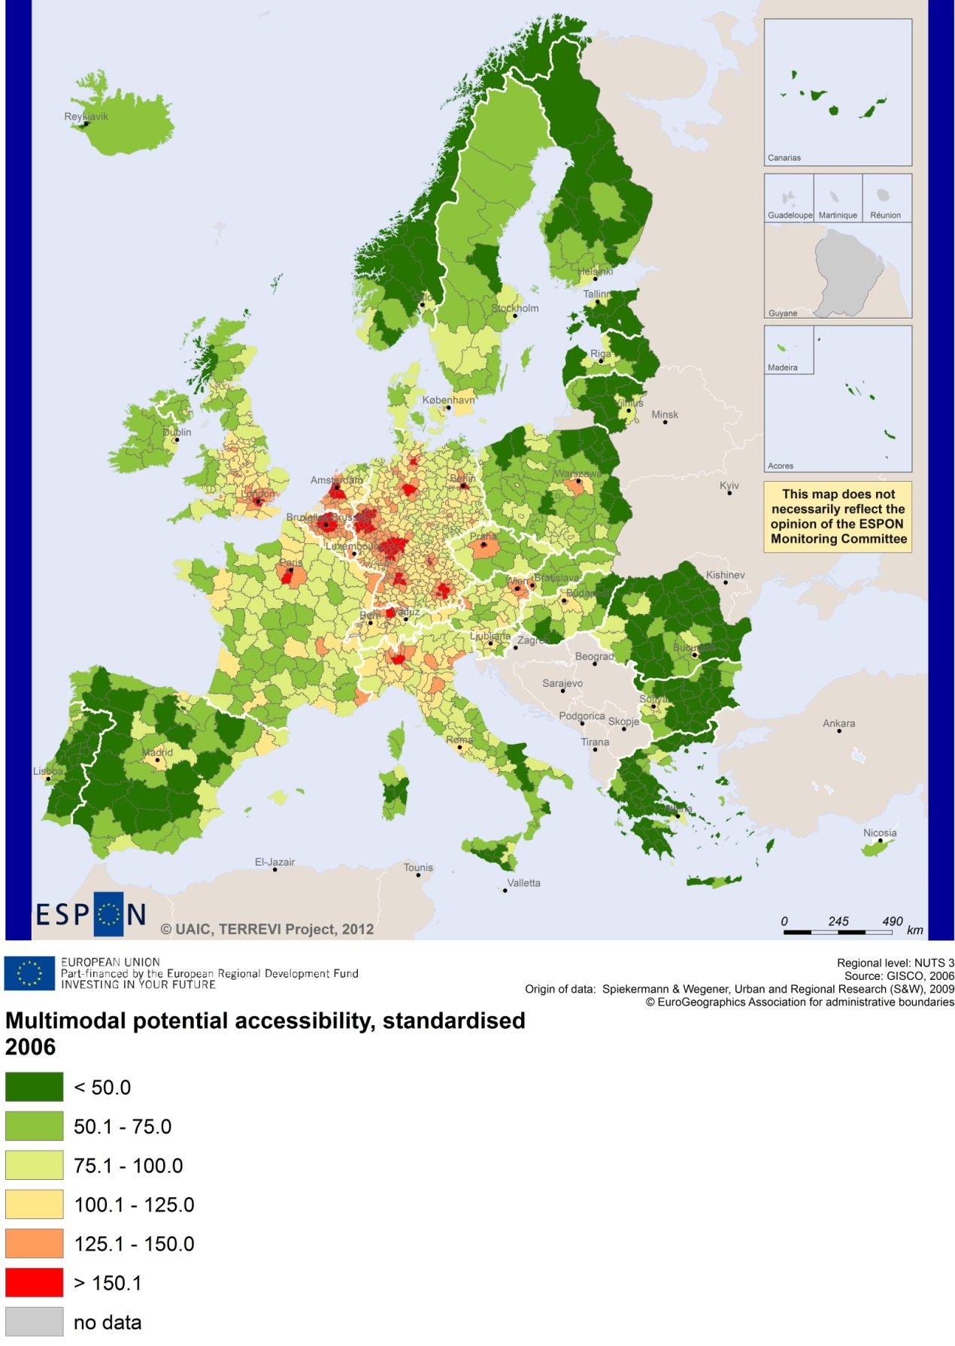

Recommended ESPON reading
ESPON provides an essential underpinning for translating into practice the calls for integrated and place-based approaches to economic development, when analysing a programme area or deciding about future programme priorities. ESPON has published a wide range of exciting reports providing valuable territorial evidence for future territorial cooperation initiatives.
The table below shows examples of relevant projects for the Cooperation Region. However, you have to study other ESPON reports as well in order to capitalise fully on the European information available for the transnational programming.
ESPON study | Topic | Content
TRANSMEC | European cooperation | It develops general tools to support territorial cooperation programmes in capitalisation and considerations on future strategic project development (see map 27 and from map 36 to 39 on potential accessibility indicators). The method is applied for the Northwest-Europe cooperation area.
SEMIGRA | Rural migration | It identifies the main reasons and consequences of selective migration in rural regions (see map 1, 4 and 5). The case studies include Västernorrland in Sweden and Kainuu in Finland.
DEMIFER | Demography | It provides evidence on the regional effects of migration on Europe's demographic future. The case studies include Mecklenburg-Vorpommern (Annex D12-3), Sydsverige (Annex D12-10) as well as reference to Hovedstaden and Sjælland in Denmark.
ReRisk | Energy | The project focuses on opportunities to support competitive and clean energy supplies for regions in Europe and to generate and strengthen sustainable energy sources. The case studies include Kalmar county in Sweden and the island of Samsø in Denmark.
TERCO | Territorial cooperation | The project provides an assessment of existing territorial cooperation areas and their territorial development challenges and potentials. The case studies include the programme areas Finland-Russia, Poland-Slovakia-Ukraine, Poland-Germany-Czech Republic, and Scotland-Norway-Sweden.
SGPTD | Growth poles | It provides evidence on European secondary cities, their performance and functional roles in different parts of Europe, and the potential policy intervention affecting their performance (see from figure 2 to 2.12). The project includes one case study on the city of Tampere in Finland.
GEOSPECS | Specific types of territories | It provides evidence on the strength, weaknesses and development opportunities of specific types of territories and regions (e.g. border areas, highly or sparsely populated areas). The case studies include the Torne Valley (Sweden and Finland) and the Czech-German-Polish border.
EUROISLANDS | Islands | It gives evidence on the divergence of island's situation from the European average and on existing policy measures for the islands. The case studies include the Åland Islands (FI), Saaremaa (EE), and Samsø (DK).
SURE | Convergence regions | It focuses on the specific challenges of development of convergence regions within the EU and it seeks to understand why some convergence regions are unable to improve economic performance and competitiveness. One of the case studies is on Podlasie, in Poland.
PURR | Rural regions | It creates and tests new ways to explore the territorial potentials of some rural areas and small and medium-sized towns in peripheral parts of Europe around the North Sea, the Irish Sea and the Baltic Sea. The case studies include Notodden in Norway and Amata Vidzeme in Latvia.
RISE | Integrated strategies | It shows how monitoring and evaluation indicators and methodologies can be used to enhance the development of Regional Integrated Strategies. The case studies include Randstad, in the Netherlands, Västerbotten I Sweden and Zealand, in Denmark.
KIT | Innovation | It describes patterns and potentials of regions in terms of knowledge and innovation economy and explores development opportunities (see from map 3.1.1 to 4.4.1). It provides some case studies on Cambridge, Oxford, Cardiff and West Wales (see Draft Final Scientific Report, Vol. 2, 3).
Furthermore, some of overall ESPON products of particular interest for territorial cooperation are:
- ESPON Synthesis report “new evidence on smart, sustainable and inclusive territories” provides an easy to read overview on ESPON results available.
- ESPON Territorial Observations is a publication series, which on a few pages presents policy relevant findings deriving from latest ESPON research.
- ESPON 2013 Database provides regional information provided by ESPON projects and EUROSTAT.
- ESPON Hyperaltas allows comparing and analysing a region’s relative position at European, national and local scale for a wide range of criteria.
- ESPON MapFinder provides access to the most relevant ESPON maps resulting from ESPON projects and reports.
- ESPON Typologies provides nine regional typologies for additional analysis of regional data to be considered in the European context.
All ESPON reports and tools are freely available at
www.espon.eu

The ESPON 2013 Programme is part-financed by the European Regional Development Fund, the EU Member States and the Partner States Iceland, Liechtenstein, Norway and Switzerland. It shall support policy development in relation to the aim of territorial cohesion and a harmonious development of the European territory.

